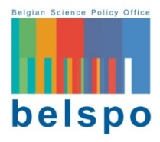
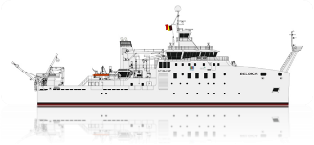
New RV Belgica
Specific call for research proposals 2021

INSTITUTION REQUEST FORM
If your research institution is not in the list of eligible partners on the submission platform, you can complete this Institution Request Form and send it to Belgica_call@belspo.be . Only requests accompanied by the completed Institution Request Form and the necessary annexes will be evaluated.

To be eligible being a project partner and receiving BELSPO funding, your institution must demonstrate that it belongs to the non-profit sector and that its articles of association clearly contain the pursuit of scientific research.

Name of the Institution: | Click here to enter text.
Acronym of the Institution: | Click here to enter text.
Legal form: | Click here to enter text.
Name of the Director: | Click here to enter text.
Contact person: | Click here to enter text.

Full address: | Click here to enter text.

Tel: | Click here to enter text. | Email: | Click here to enter text.

Website:

EVIDENCE OF SCIENTIFIC ACTIVITY

Refer here to the part of the articles of association of your organisation where scientific activities are mentioned. Annex the full articles of association to this Form.

Part of the articles of association where scientific research is mentioned:
Click here to enter text.
Describe and provide evidence of recent research activities and public grants eventually received:
Click here to enter text.

The State reserves the right to request additional information and/or evidence to complete the eligibility evaluation.

COMMITMENT

The undersigned, Click here to enter text., acting in the capacity of Click here to enter text. within the above-mentioned research institution, declares that this notification and the accompanying documents are true and sincere.

Drawn up in Click here to enter text. on Click here to enter a date.

Electronic signature:

