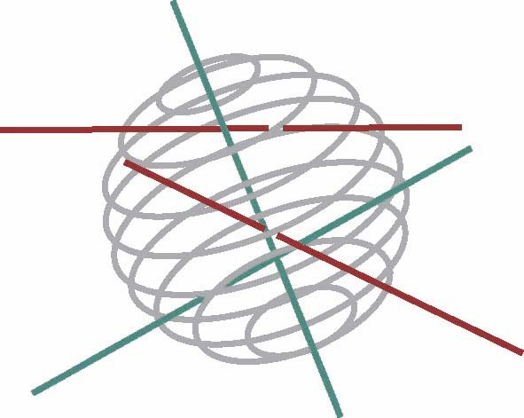

BELGIAN FEDERAL PUBLIC
PLANNING SERVICE
SCIENCE POLICY

Research programme
Science for a Sustainable Development (SSD)

Call for proposals nr 2

Energy, Transport and mobility, Agro-food, Health and environment, Biodiversity, Terrestrial (incl freshwater) and marine ecosystems of the North Sea, and Transversal research

Expression of interest

Closing date: 17 March 2006

To be sent to SSD_call2@belspo.be

Mandatory for the submission of a research proposal

Proposal’s title (maximum 12 words) :
…

Research area(s) (more than one is possible):

Energy
Transport and mobility
Agro-food
Health and environment
Biodiversity
Ecosystems : Terrestrial (incl. freshwater)
North Sea
Transversal research

Name of the coordinator: | …
Institution: | …
Department: | …
E-mail: | …

Possible partners (name and institution):
…

Short description of the research proposal (domain, objectives, methodology,…):
(maximum 15 lines)
…
Keywords (maximum 6):
…

