 | BELGIAN  SCIENCE POLICY OFFICE  Avenue Louise 231 Louizalaan B-1050 Brussels  Tel. +32 2 238 34 11 Telefax +32 2 230 59 12  www.belspo.be | 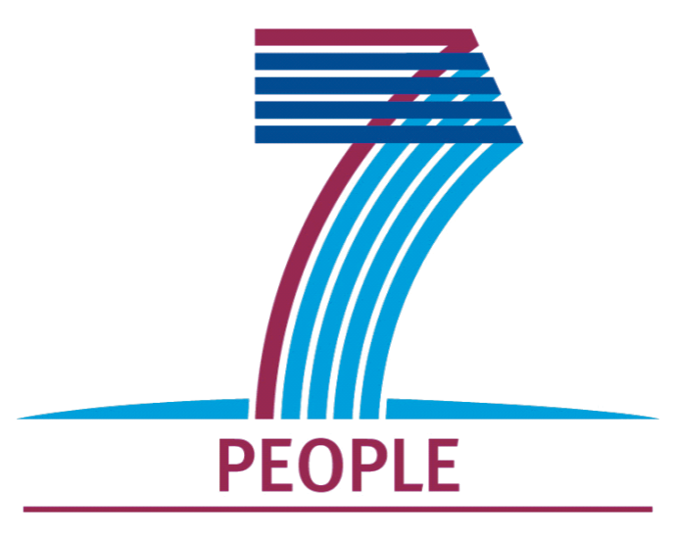

INTERNATIONAL S & T COOPERATION :

POST-DOC FELLOWSHIPS TO NON-EU RESEARCHERS

Information note
Selection 2012

Brussels, 21 November 2011

1. Aim of the action

The stimulation of international mobility and the attraction of researchers from abroad is one of the priorities of the European Research Area.
The Federal Science Policy Office, together with the Marie Curie Actions of the European Commission (FP7-PEOPLE- COFUND-2008), is contributing to this objective by granting post-doc fellowships to highly qualified non-EU scientists inviting them to work in a Belgian research team during a certain period of time. The ultimate aim is to establish S&T collaborations and lasting networks between the respective research teams.

2. Who can apply?

Qualifications required to be eligible:
- holding a doctor’s degree or have a similar research experience (minimum 5 years);
- being born after 1961;
- having the nationality and perform research in one of the target countries.

The target countries:
Are those countries with which Belgian Reseach Institutions wish to strengthen cooperation and for which not sufficient alternatives are available.
However, are not considered: EU Member States, countries associated to the 7th Framework Programme nor those of the list below .

3. Duration of the stay : from 6 to 18 months

Exceptionally, the stay can be divided in 2 periods, subject to approval by the Federal Science Policy Office on the basis of a motivated request.

4. Belgian host institutions

Such S&T collaborations however, must take place in the frame of ongoing research activities financed by the Federal Science Policy Office. Consequently, at the time of application, the Belgian host organisation and promoter must be involved in the execution of a federal research programme or belong to a federal scientific institution.

Information regarding these programmes, related research projects, host organisations and promoters is available on the website http://www.belspo.be, rubric "FEDRA".

5. Submission of applications

The application forms are introduced both in hard and electronic copy (swen@belspo.be) to the Federal Science Policy Office by the Belgian promoter and have to be accompanied by:
- a list of scientific publications of the candidate;
- a description of the research project to be performed during the sojourn;
- a recommendation letter from the director of the candidate's home institute describing the added value of the mission and confirming the possibility that the fellowship holder will be able to resume his/her activities after his/her stay in Belgium and mentioning prospects for further cooperation;
- a motivation letter from the Belgian promoter.

The application will contain some keywords to identify the field of research in order to find the most appropriate jury.

Only complete applications will be taken into consideration.

6. Evaluation and selection

The selection will take place by an external multidisciplinary examining-board under the presidency of the Federal Science Policy Office.

The evaluation criteria concern:
- the scientific merits of the candidate (curriculum vitae, publications...);
- the content of the proposed research project:
i.e. *linkage with the ongoing activities of the host unit;
*relevance to the expertise of the candidate;
*feasibility of the study in the proposed time;
- the potential transfer of knowhow and prospects for further cooperation.

The selection of the candidates takes place once a year. The call for proposals for the selection 2011 will be published on our website (http://www.belspo.be) and on the site of Euraxess (http://ec.europa.eu/euraxess/). Belgian institutes will be informed by letter on this call in November 2010.
The deadline for application is Monday 5 March 2012 at 17:00 hour.

The result of the selection will be communicated to the concerned Belgian project leader who is responsible for the correspondence with the applicant.

The selected candidates should start their research stay not later than 15 months after the deadline
of the call for proposals.

7. Budget

The fellowship comprises:
- a net monthly allowance of 2.000 EUR;
- a single payment of 1.250 EUR for the travel expenses from and to the country of origin;
- the personal liability insurance costs;
- the contribution to the National Office of Social Security (NOSS), as foreseen by
Royal Decree of 26.03.2003 in relation to foreign workers (M. B. of 28.04.2003).

Remark : The Royal Decree of 07.01.1989 foresees that fellowships to scientists are free of taxation when paid by the Belgian authorities or institutions such as universities.

Depending on the duration of the stay, about 30 fellowships will be granted for the whole of the considered countries.

The host institution will, to the account of the Federal Science Policy Office, be responsible for the (monthly) payments of the invited scientists as well as for the subscription of the insurances. The Federal Science Policy Office will reimburse the institution every three months, after having received a debit note with proofs of the expenses.
The last reimbursement will be executed only after receipt of the final activity report (cf.9).

8. Visa

The European directive, known as the "scientific visa", has been fully transposed to Belgian law with the following consequences :
- the procedure for obtaining a visa and residence permit for any third-country researcher who has signed a hosting agreement with a previously- approved research organisation has been simplified; - - any researcher coming to Belgium in the framework of such an agreement is also exempted from the work permit requirement.

On the basis of this hosting agreement signed by both parties, the researcher can submit an application for a residence permit lasting longer than three months to the Belgian diplomatic or consular post in the country of origin.

Once in Belgium, the researcher should register in the town of his/her new residence (even if it is temporary) within 8 days after arrival. On the other hand the host institution has to inform the appropriate authority (the Immigration Service of the concerned Region) about the arrival date of the grantee at the latest within one month and send to that authority a copy of the hosting agreement as well as a copy of the first page of the passport of the researcher.

In the case of accompanying families, even for a short visit, it is advised to start the procedure at the same time as that for the fellowship holder.

Details about this” scientific visa” can be found on the website http://www.belspo.be/visa.

9. Reports

  - Mid-term report
At mid-term, the fellowship holder, in concertation with the Belgian promoter(s), has to report in brief (maximum 3 pages) to the Federal Science Policy Office about the progress of the research activities, potential difficulties and perspectives. For fellowships up to 9 months only a final report is due.

  - Final report
At the end of the stay, within the following trimester, a more detailed scientific report (maximum 15 pages) is
due.
It will be published on our website.
The report presents a detailed recapitulation of the research objectives and used methodologies and gives a comprehensive description of the results and conclusions.
A list of publications, missions and contributions to scientific meetings has to be added with a copy of the page where the mention described under point 10 is to be found.

In an accompanying letter, the project leader will point out to what extend the objectives were met. He also will give an appreciation on the added value of the stay for the researcher, the hosting institution and the prospects for further collaboration.

Finally, a summary of maximum 1 page, including a few keywords, is requested, for internal use by the Federal Science Policy Office (website, FEDRA database, ...).

If appropriate a separate report of compliance with ethical rules will be asked.

These documents have to be sent electronically to swen@belspo.be.
.

10. Publications

Every publication or event connected to the sojourn should mention that the concerned author is a beneficiary of a mobility grant from the Belgian Federal Science Policy Office co-funded by the Marie Curie Actions from the European Commission.

* * *
* *
*

This information note as well as the application form is available on the website of the Belgian Science Policy: http://www.belspo.be
Research & return grants
Post-doc fellowships to non-EU researchers

----------------------------------------------

For further particulars contact
Mr F. Swennen ( 02/238.34.36 , swen@belspo.be)

-----------------------------------

Switzerland, Israel, Norway, Iceland, Liechtenstein, Turkey, Croatia, Macedonia, Serbia, Albania, Montenegro, Bosnia-Herzegovina, Moldova.
Qatar, Singapore, Brunei, United Arab Emirates, USA, Australia, Canada, Kuwait, Taiwan, Japan, Bahamas, South Korea, New Zealand, Bahrain, Oman, Seychelles, Barbados, Saudi Arabia.

