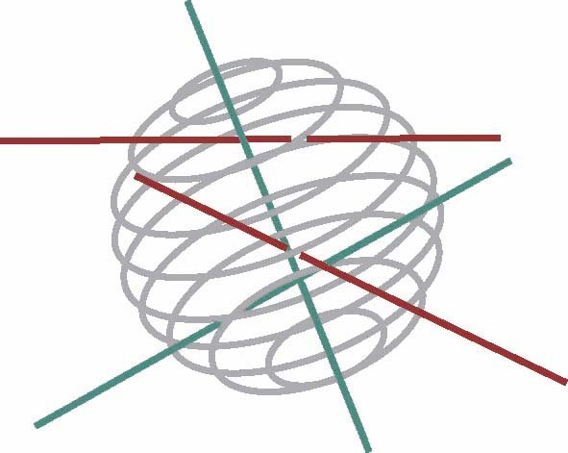

BELGIAN SCIENCE POLICY
Louizalaan 231 Avenue Louise
B-1050 BRUSSELS
Tel. +32 2 238 34 11 ▪ Fax +32 2 230 59 12
www.belspo.be

ACTIVITY REPORT INTENDED FOR THE INTERMEDIARY EVALUATION

DOCUMENT G

CONTRACT NUMBER ../../...

Project title

SCIENCE FOR A SUSTAINABLE DEVELOPMENT

for the period: ../../.... to 31/07/08

Date : ../../..

COntact information

Coordinator: [name and coordinates]

OTHER PARTNERS:
- [name and institution]

- [name and institution]

- ...

AUTHOR(S): [name and institution]

PROJECT WEBSITE(S):

Please refer to the document F « Guidelines for the intermediary evaluation report »
for a definition of the different sections

ACRONYMS, ABBREVIATIONS AND UNITS

1. INTRODUCTION

1.1 Context

1.2 Objectives and expected outcomes

2. CONFORMITY WITH THE INITIAL PLANNING

2.1 Workplan

2.2 Use of the resource

3. COLLABORATION AND SYNERGY WITHIN THE NETWORK

4. REPORT OF THE PROGRESS AND IMPLEMENTATION OF THE METHODOLOGY

5. Preliminary conclusions and recommendations

6A. prospects and planning UNTIL THE END OF PHASE 1 (for projects of 4 years) OR UNTIL THE END OF THE PROJECT (for projects of 2 years)

7. FOLLOW-UP COMMITTEE

8. PUBLICATIONS / VALORISATION

8.1. Publications of the teams

8.1.1. Peer review

8.1.2. Others

8.2. Co-publications

8.2.1. Peer review

8.2.2. Others

8.3 Other activities

9. SUPPORT TO THE DECISION

10. DISSEMINATION OF THE RESULTS (only for projects of 2 years)

11 . SCIENTIFIC PERSPECTIVES (only for projects of 2 years)

The annexes will only be electronically available for the experts :

ANNEX 1 : COMPLEMENTARY INFORMATION

ANNEX 2 : COPY OF THE PUBLICATIONS

ANNEX 3 : MINUTES OF THE FOLLOW-UP COMMITTEE MEETINGS

