

P4Science
BELSPO Platform
EoI Submission Manual
2026

Contents
Foreword (page 3)
Before you begin (page 3)
Quick guide for experienced evaluators (page 4)
Glossary of Terms (page 5)
1. Access & Registration to the Platform 6
1.1. ACCESS THE PLATFORM 6
1.2. FIST-TIME USERS: REGISTER AS A CONTACT IN THE PLATFORM 7
1.3. GETTING FAMILIAR WITH THE DASHBOARD 8
1.4. REGISTER TO AN ORGANISATION IN THE PLATFORM 9
1.5. YOU MUST WAIT TO SUBMIT AN EXPRESSION OF INTEREST UNTIL BELSPO APPROVES YOUR REGISTRATION 11
2. Apply to the P4Science programme 12
2.1. ALREADY REGISTERED USERS: LOG IN TO THE PLATFORM 12
2.2. IF YOU ARE NO LONGER WORKING FOR THE SAME ORGANISATION AS BEFORE 13
2.3. APPLY FOR FUNDING IN THE P4Science PROGRAMME 13
3. Enter, edit and submit an Expression of Interest 15
3.1. GETTING FAMILIAR WITH THE EXPRESSION OF INTEREST FORM 15
3.2. FILL IN SECTION 1. GENERAL INFORMATION 16
Question 1.1. Application ID 16
Question 1.2. Project Classification 17
Question 1.3. Optional sections in the Expression of Interest form. 17
Question 1.4. Declarations 18
Attention! Non-editable fields 18
3.3. FILL IN SECTION 2. SUMMARY 18
Question 2.1. Summary 18
Attention! Editable & non-editable fields 19
3.4. FILL IN SECTION 3. COORDINATOR 19
Question 3.1. Organisation details 19
Question 3.2. Promotor (Principal Investigator) 20
Attention! Non-editable fields 20
3.5. FILL IN SECTION 4. FUNDED PARTNER(S) INFORMATION 21
Question 4.1. Partner Information 1 > 4.1.1 Organisation details 21
Question 4.1. Partner Information 1 > 4.1.2 Promotor (Principal Investigator) 22
Attention! Non-editable fields 22
Question 4.2. Partner Information 2 > 4.2.1 Funded Partner 22
Edit or delete Funded Partners in the Expression of Interest 23
Attention! Submission is impossible with uncompleted fields in Funded Partners’ section. 24
3.6. FILL IN SECTION 5. PROPOSED EVALUATORS 24
Question 5.1. Proposed Evaluators 1 > 5.1.1 Proposed Evaluators 24
Question 5.2. Proposed Evaluators 2 > 5.2.1 Proposed Evaluators 25
Edit or delete Proposed Evaluators 26
Attention! Submission is impossible with uncompleted fields in Funded Partners’ section. 27
3.7. FILL IN SECTION 6. NON-GRATA EVALUATORS 27
Question 6.1. Non-Grata Evaluators 1 > 6.1.1 Non-Grata Evaluators 27
Question 6.2 Non-Grata Evaluators 2 > 6.2.1 Non-Grata Evaluators 28
Edit or delete Non-Grata Evaluators 29
Attention! Submission is impossible with uncompleted fields in Non-Grata Evaluators section. 29
3.8. SUBMIT EXPRESSION OF INTEREST 30
Attention! Submission will FAIL… 30
4. Access (and edit) your Expression of Interest in the Platform 31
4.1. BEFORE YOU HAVE SUBMITTED THE EXPRESSION OF INTEREST 31
Under Upcoming Tasks: 31
Under My Applications: 32
4.2. AFTER YOU HAVE SUBMITTED THE EXPRESSION OF INTEREST 32
Under My Applications: 32
The Application page: 33
5. Delete your Expression of Interest in the Platform 35

FOREWORD
This manual is a practical guide to submit an Expression of Interest to the P4Science programme. All Expressions of Interest of the P4Science programme must be submitted using the BELSPO Platform.
Expressions of Interest can only be created, edited and submitted by their Coordinator. In the P4Science programme the coordinator must belong to a Federal Scientific Institution.
Please read the P4Science Information File available on the BELSPO website before creating an Expression of Interest. A draft template of the Expression of Interest is also available on the website to prepare the submission. Note that this template cannot be uploaded to the platform; information must be directly entered online.
Information File:
https://www.belspo.be/belspo/P4Science-S4Policy/call/P4Science_2026/P4S_call2026-27_InfoFile.pdf
Expression of Interest template : https://view.officeapps.live.com/op/view.aspx?src=https%3A%2F%2Fwww.belspo.be%2Fbelspo%2FP4Science-S4Policy%2Fcall%2FP4Science_2026%2FP4S_call2026-27_Expression-of-Interest-template.docx&wdOrigin=BROWSELINK
Questions :
P4Science programme: P4Science@belspo.be
BELSPO platform: platform.support@belspo.be

BEFORE YOU BEGIN
Please ensure that…
- You are affiliated to one of the 11 FSI that may submit applications in P4Science.
- You have the authorisation of your Director General to submit an application as Coordinator of the project.
- You have read the Information File, and that you understand the Strategic Research Areas of the Call and the Toolbox.
- You have identified the Funded Partners that will work with you in the project. (If applicable)
- You have identified at least 4 Proposed Evaluators (maximum 6) that are eligible.

QUICK GUIDE
For experienced coordinators who are still affiliated to the same organisation of previous calls.
- Log in to the platform with your existing email and password.
https://belspo.aimsgrants.com/AUUID/071DDF788
- Click on the Piggy-bank icon on the left upper corner of the page.
- Select P4Science 2026 Call – Apply now.
- Fill in the form …
- Section 1. General Information
Beware that the choices made in this section cannot be changed in the Full Proposal.
State whether there are Funded Partners and Non-Grata Evaluators, to enable/disable the corresponding sections in the form.
- Section 4. Proposed Evaluators
Introduce min. 4 Proposed Evaluators.
- Attention !
Leave no empty tabs for Funded Partners, Proposed and Non-Grata Evaluators.
- Submit.



GLOSSARY OF TERMS

Application: The combination of an Expression of Interest and its Full Proposal.
Contact: The profile of a person in the Platform.
Coordinator: The institution that coordinates the project and receives funding from the project. They appear in both the Expression of Interest and the Full Proposal. The Coordinator is responsible for creating, editing, and submitting these documents. In the Full Proposal the Coordinator appears in the Work Plan and the Gantt chart, performing tasks. When the details of the Coordinator are requested in the Expression of Interest and Full Proposal forms they refer to the Promotor, the person that will be signing the Contract if the project is selected for funding, and that will be responsible of performing the project’s tasks on behalf of their institution.
Funded Partner: The institution that is part of the project’s consortium and receives funding from the project. Funded Partners belong to institutions different than that of the Coordinator, and are coordinated by the Coordinator. Funded Partners appear both in the Expression of Interest and the Full Proposal. In the Full Proposal, Funded Partner appears in the Work Plan and the Gantt chart, performing tasks. When the details of the Funded Partner are asked in the Expression of Interest or Full Proposal form, they refer to the Promotor, the person that will be signing the Contract if the project is selected for funding, and that will be responsible for performing the project’s tasks on behalf of their institution.
Non-Funded Partner: Institution that provides substantial contribution to the project, either in kind or with cash (they do not receive funding from the project). Non-Funded Partners belong to institutions different than that of the Coordinator and Funded Partners, and are coordinated by the Coordinator. Non-Funded Partners are requested only in the Full Proposal and do not appear in the Expression of Interest. In the Full Proposal, Non-Funded appear in the Work Plan and the Gantt Chart performing tasks. When the details of the Non-Funded partner are requested in the Full Proposal, they refer to the person performing the project’s tasks on behalf of their institution. If the project is selected for funding, Non-Funded partners do not sign the Contract.
Non-Grata Evaluator: An evaluator indicated by the applicants that is not to review their Full Proposal. BELSPO will not choose this person to evaluate the Full Proposal.
Organisation: Institution.
Promotor: The person that is performing the project’s tasks on behalf of their institution (the Principal Investigator).
Proposed Evaluator: An evaluator suggested by the applicants to review the quality, feasibility and potential impact of their Full Proposal. Proposed evaluators must be free of conflicts of interest. BELSPO may include proposed evaluators in the team of reviewers for the Full Proposal for which they have been suggested.

Access & Registration to the Platform
The Coordinator creates, edits and submits the Expression of Interest. This task cannot be delegated. The Coordinator must register in the platform TWICE.

- First, they have to register themselves as contacts in the platform.
- Second, they have to register themselves to an organisation in the platform.

1.1. ACCESS THE PLATFORM
Access the BELSPO Platform here: https://belspo.aimsgrants.com/AUUID/071DDF788
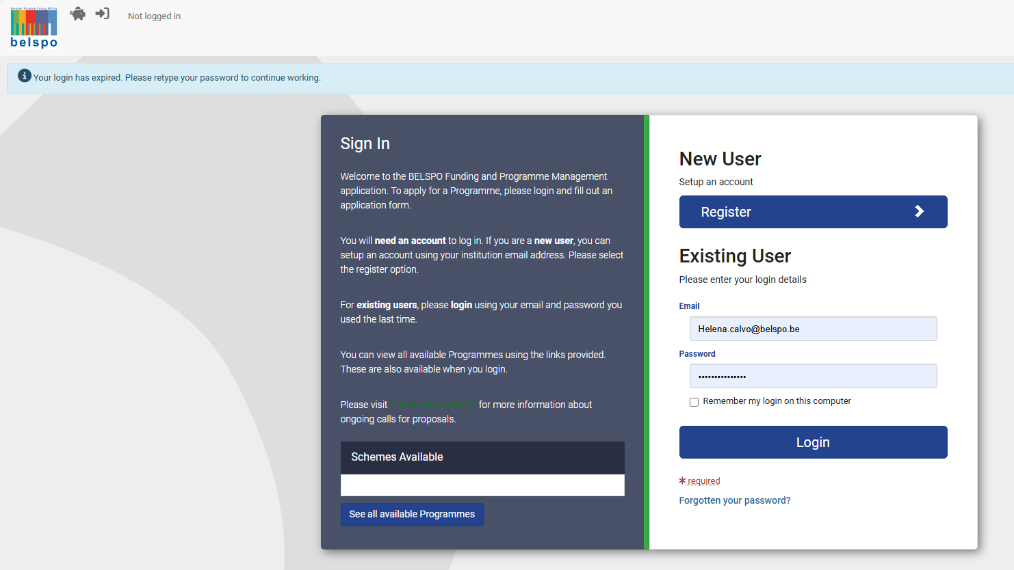

1.2. FIST-TIME USERS: REGISTER AS A CONTACT IN THE PLATFORM
If you are NOT a first-time user, please skip to Section 2. Of this manual (Apply to the P4Science programme).
If you are a first time user, click on Register.
Enter your details and tick the ‘I agree my data will be stored’ box. Click on Register.
Use your professional email address – the email from your organisation.
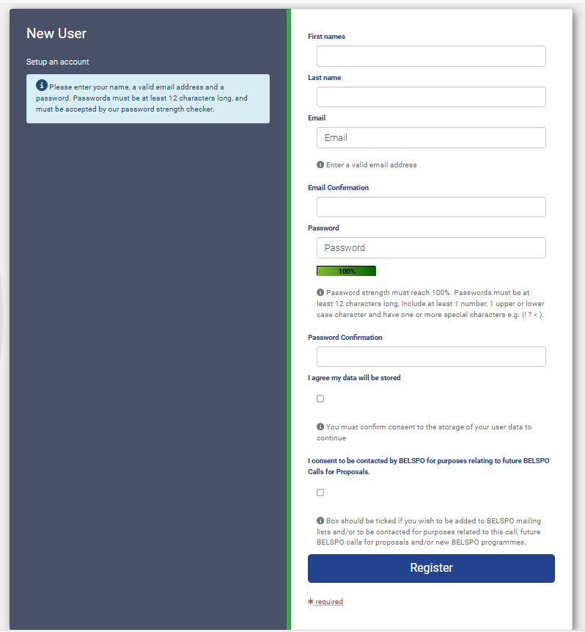

The Platform will request an authentication code. This authentication code will be sent to you by email:
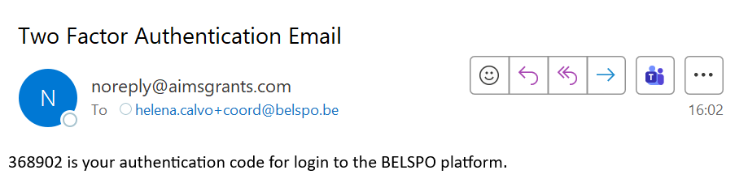
coord@org.be
Enter the Authentication code. Click on Submit.
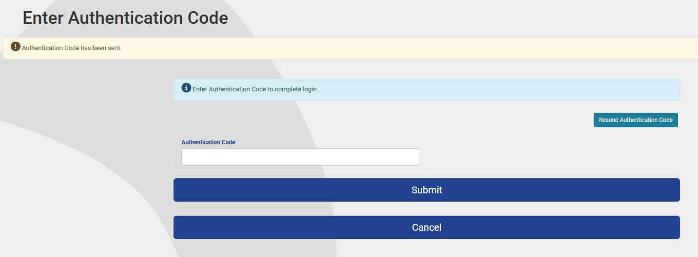
You will land on your Dashboard.

1.3. GETTING FAMILIAR WITH THE DASHBOARD
The Dashboard is your home page in the Platform. It is made of different sections:
- Welcome: welcome message with 2 buttons:
Edit my details – allows you to edit your personal details
Register an organisation – allows you to link yourself to an organisation
- How to apply for funding? general information on how to apply to the different BELSPO programmes
- Upcoming Tasks : here you will find all your pending tasks in relation to your applications
- My Applications : here you will find the list of all your applications and their status
- See all available programmes: leads you to the BELSPO open programmes

- First, they have to register themselves as contacts in the platform.
- Second, they have to register themselves to an organisation in the platform.

You can always come back to the Dashboard by clicking on the Paper-tray icon.
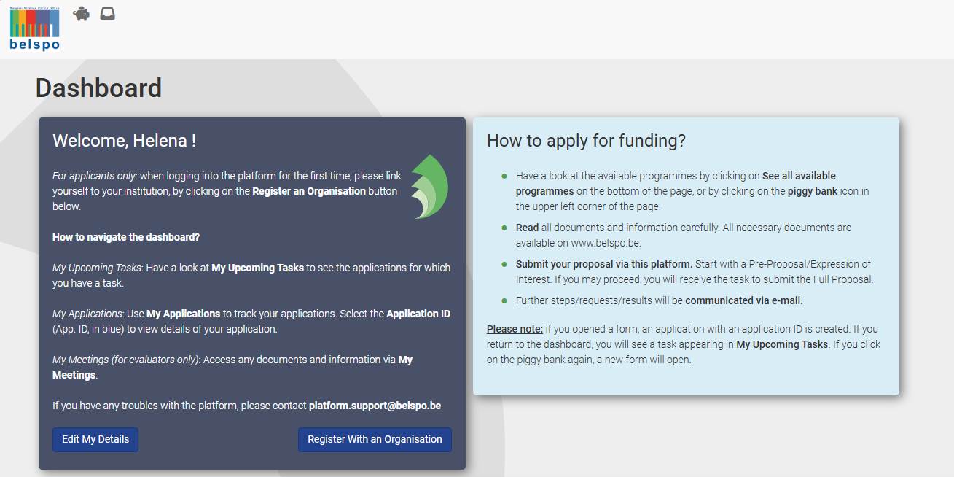

1.4. REGISTER TO AN ORGANISATION IN THE PLATFORM
The Coordinator of any P4Science proposal must belong to one of the following Federal Scientific Institutions. These institutions appear in English in the BELSPO Platform:

- Royal Belgian Institute for Space Aeronomy
- Royal Belgian Institute of Natural Sciences
- Royal Institute for Cultural Heritage
- Royal Library of Belgium
- Royal Meteorological Institute of Belgium
- Royal Museum for Central Africa
- Royal Museums for Art and History
- Royal Museums of Fine Arts of Belgium
- Royal Observatory of Belgium
- State Archives
- War Heritage Institute

Note that Sciensano and the National Institute of Criminalistics and Criminology cannot be coordinators in P4Science call 2026.

- First, they have to register themselves as contacts in the platform.
- Second, they have to register themselves to an organisation in the platform.

Scroll down to Upcoming Tasks.
Under Organisation Name, enter the name of your institution in English.
Click on Search.
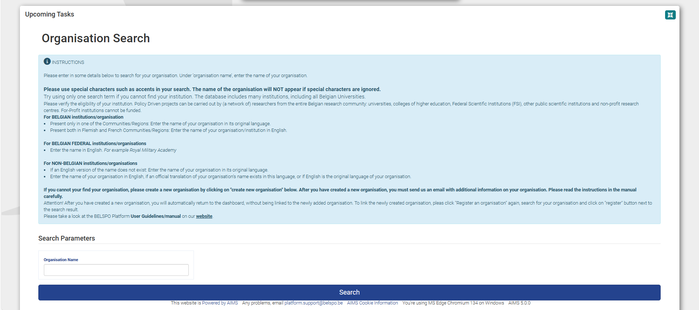
The name of your institution will under the Search button.
Click on the Register button next to your institution.
Note: If you are using a smaller screen, such as the one of a laptop, you may not see this button, which is at the right of the page. You can scroll horizontally on the page using the bar, or by pressing CTRL on your keyboard and clicking on the left side of your mouse.
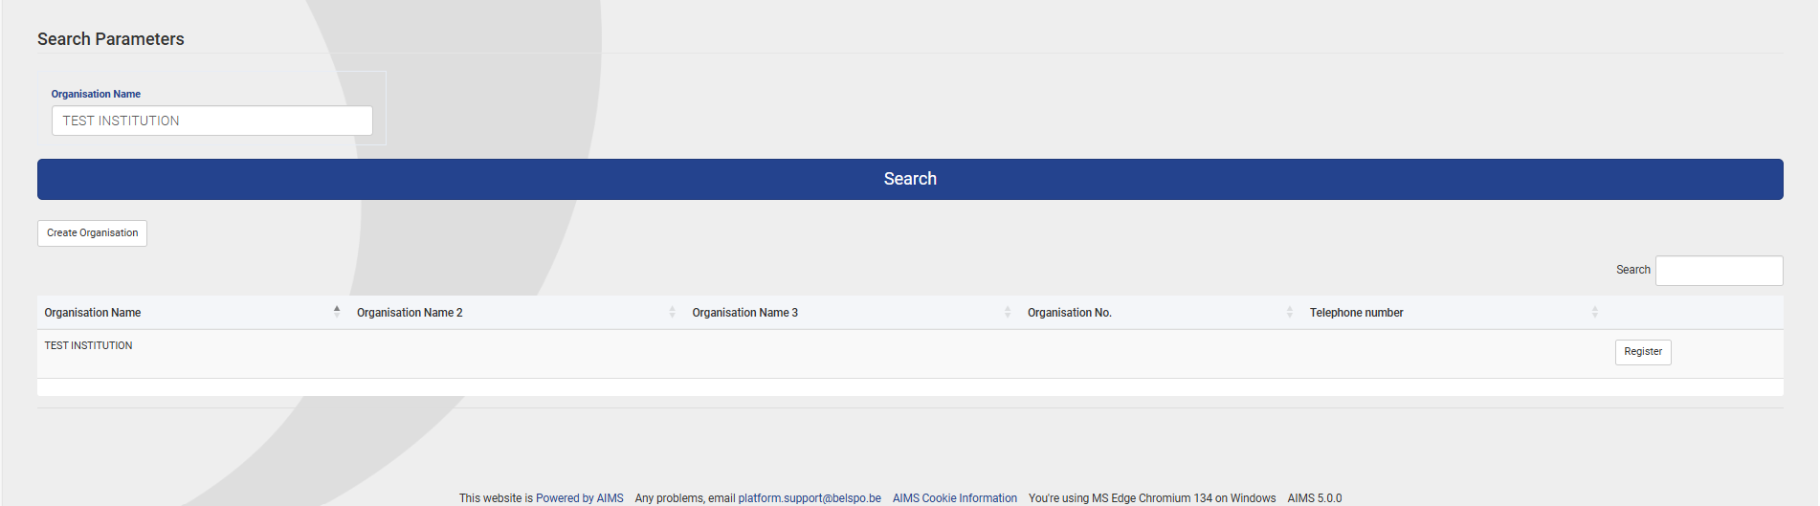
You will be back to the Dashboard. A message will appear thanking you for your registration:
‘Thank you for registering your association with Organisation xxx. Your registration needs to be approved before you cane either create applications on behalf of the organisations or have access to edit/view organisations details’

1.5. YOU MUST WAIT TO SUBMIT AN EXPRESSION OF INTEREST UNTIL BELSPO APPROVES YOUR REGISTRATION
BELSPO needs to approve your registration to an organisation before you create an Expression of Interest. If you do not wait, you will not be linked to your institution and will have to re-submit the Expression of Interest. Once your registration to an organisation has been approved by BELSPO, you will receive an email from the BELSPO Platform, and you will be able to proceed with the submission.

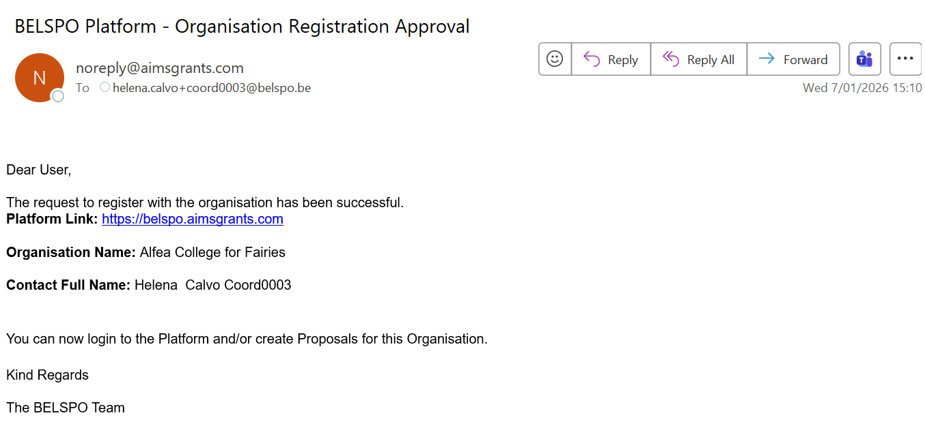
coord@org.be
Coordinator’s First Name and Last Name
Coordinator’s Organisation

Apply to the P4Science programme

2.1. ALREADY REGISTERED USERS: LOG IN TO THE PLATFORM
Under Existing User, enter the email address you have used for registration and your password. Click on Login.

The Platform will request an authentication code. This authentication code will be sent to you by email:
coord@org.be

Enter the Authentication code in the Platform. Click on Submit.
You will land on your Dashboard.

2.2. IF YOU ARE NO LONGER WORKING FOR THE SAME ORGANISATION AS BEFORE
The system retains your affiliation with the organisation you linked yourself to in the past.
If you are working for the same organisation as in the previous submitted application, please skip this section and go to Section 2.3. of this manual (Apply for funding in the P4Science programme).
If you have changed organisation, you need to register yourself again, the new organisation. To do so, please follow the instructions given in Section 1.4. of this manual (Register to an organisation in the platform).

2.3. APPLY FOR FUNDING IN THE P4Science PROGRAMME
After logging into the BELSPO Platform, you will land on your Dashboard.
Click on the Piggy Bank icon on the top left corner of the screen, next to the BELSPO logo.
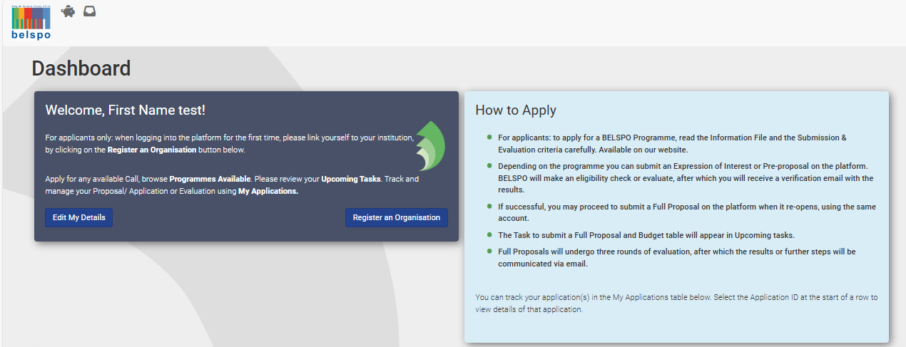

You will be directed to the Available Programmes page.
Click on the Apply now button on the P4Science box.
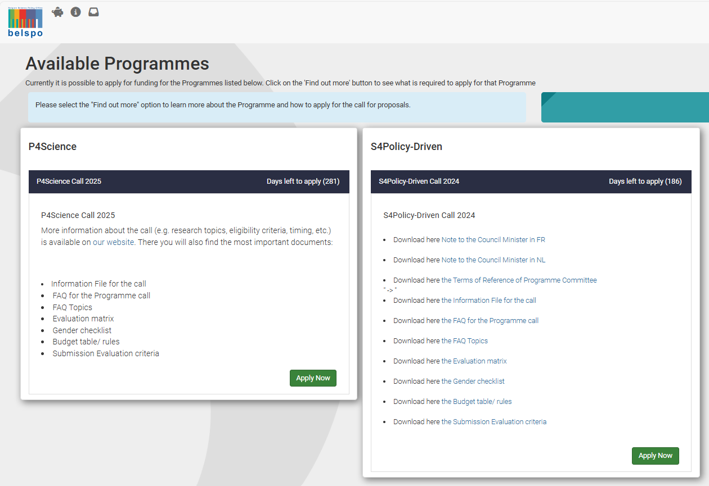
P4Science Call 2026

Enter, edit and submit an Expression of Interest

3.1. GETTING FAMILIAR WITH THE EXPRESSION OF INTEREST FORM
Sections of the Expression of Interest Form
The Expression of Interest Form is made of 6 sections, each section appears under a tab:
- General Information: Information that identifies and classifies your project.
- Summary: Title, summary of the project and keywords.
- Coordinator: Information regarding the Coordinator
- Funded Partner(s): Information regarding the Funded Partners.
- Proposed evaluators: Information of the evaluators proposed to evaluate the application.
- Non-grata evaluators: Information of the evaluators that will not be employed by BELSPO to evaluate the application.

Questions of the Expression of Interest Form
Each section contains several questions. Example: 1. Expression of Interest:
  - Application ID
  - Project Classification
  - Optional sections in the Expression of Interest form…

The blue boxes
Under the title of each question, there is a blue box.
This box contains information that provide general information regarding the question, and/or instructions on how to fill in the question.

Click on the tabs to move from one section to the other.
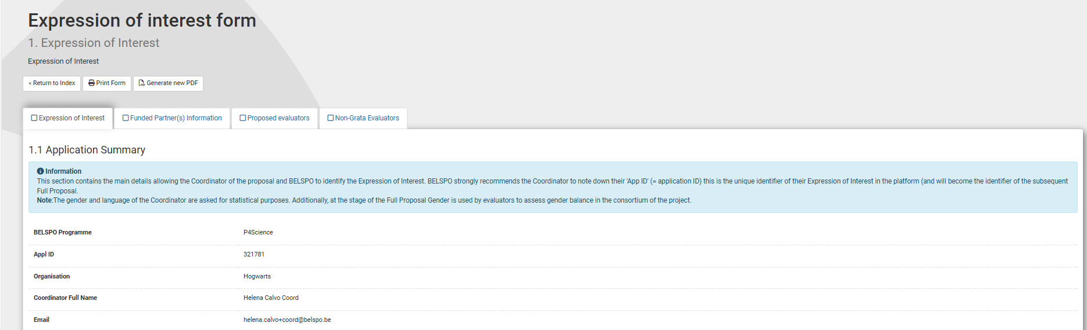
QUESTION
SECTION
TAB
BLUE BOX

At the bottom of the page:
- Click Save Draft to save the progress you to move from one section to the other.
- Click Save Draft & Continue to save the progress and move to the next section (tab).
- Click Save Draft & exit to submit the Expression of Interest.
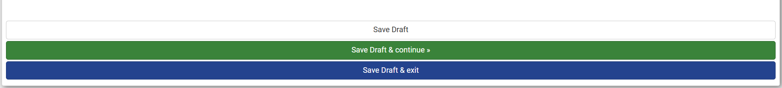

3.2. FILL IN SECTION 1. GENERAL INFORMATION
Section 1. General Information
This section cannot be modified at the level of the Full Proposal.
The General Information section is made of 4 questions:
  - Application ID
  - Project Classification
  - Optional Sections in the Expression of Interest form
  - Declarations

  - Application Summary

Question 1.1. Application ID
Under Application ID, the Coordinator must enter general information regarding the project proposal.
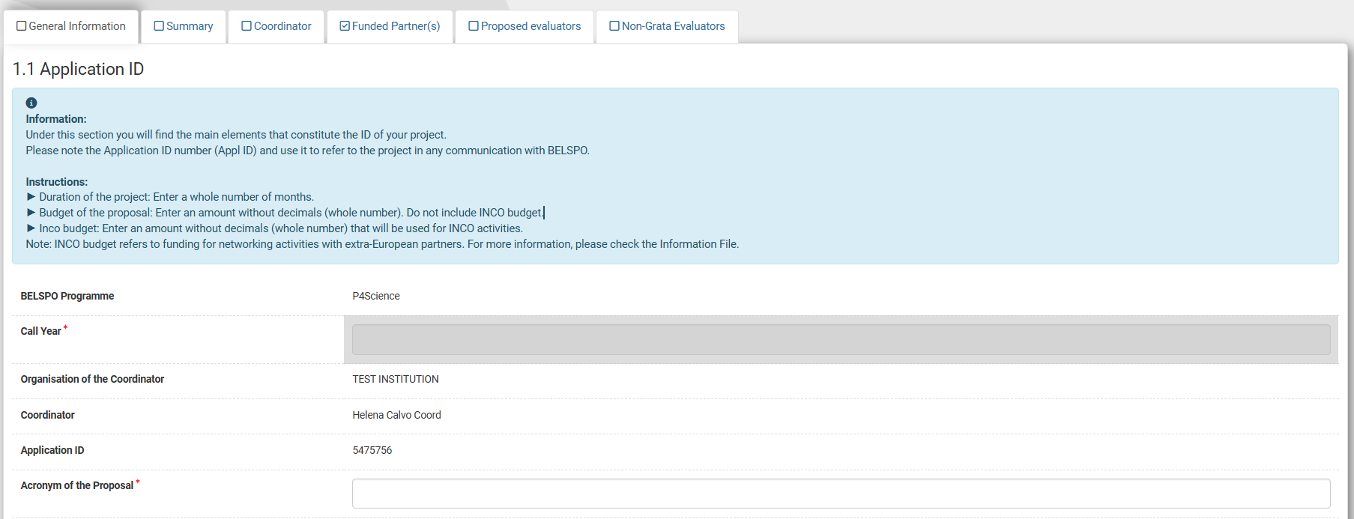
P4Science 2026 Call
The Application ID of your proposal is its unique identifier.
Please note it down, and use it in any communication with BELSPO.

- Duration: All project types have a maximum duration of 48 months. Additionally, project type ‘R&D Project’ (Toolbox Level 1) must have a minimum duration of 24 months.
- Budget: There are 2 entries for budget, the Budget of the Proposal (without INCO budget), and the INCO budget. The INCO budget is max. 30.000eur, and refers to funding for networking activities with extra-European partners – Please check the Information File for more details.

Question 1.2. Project Classification
Under Project Classification, you must specify (among other things) the Research Priorities, and the Project type (category Level 1 toolbox, category Level 2 toolbox) of your project proposal. Please read the Information File before making these choices.
- Research Priority is a multiple-choice field. You must choose at least one of the options, but you can choose more than one option.
- Project type (category Level 1 toolbox) is a single-choice field. You must choose one out of the following options: Capacity / Skill Development; R&D Project; Synergy Development; Varorisation / Impact.
- Project type (category Level 2 toolbox) is a multiple-choice field. You must choose at least one of the options, but you can choose more than one option. The options available depend of the choice made at Level 1.

Question 1.3. Optional sections in the Expression of Interest form.
Funded Partner
Belgian organisation that is part of the project’s consortium and receives funding from the project, in addition to the Coordinator. This includes: FSI, Belgian universities, Belgian colleges of higher education, and public and non-profit research centres.
Non-Grata Evaluator
An evaluator indicated by the applicants that is not to review their Full Proposal. BELSPO will not choose this person to evaluate the Full Proposal.

Answer (YES/NO) the questions regarding the Funded Partners and the Non-Grata Evaluators.

- Funded Partner: If your answer is YES, you will have to fill in section 4. Funded Partner(s).
- Non-Grata Evaluator: If your answer is YES, you will have to fill in section 6. Non-Grata Evaluators.
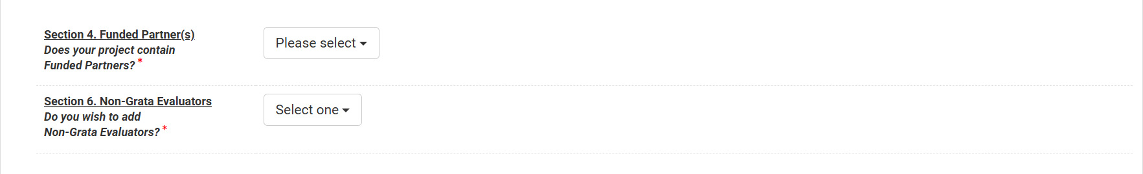

Question 1.4. Declarations
Tick the declarations regarding privacy, permission to submit, Open Access Mandate and the Code of Ethics for Scientific Research in Belgium.
There is an additional declaration regarding Artificial Intelligence, which is not mandatory and is just for information purposes (will not be used for the evaluation).
Click on Save Draft & Continue once you have completed this part of the form, to move on to the next section.
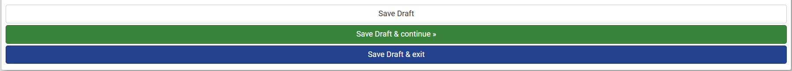

Attention! Non-editable fields
Note that fields in Section 1. Expression of Interest cannot be modified at the level of the Full Proposal. If you select Funded Partners here, you will have to complete the Funded Partner section in the Expression of Interest, and these will appear automatically in the Full Proposal.

3.3. FILL IN SECTION 2. SUMMARY
Section 2. Summary
This section can be modified at the level of the Full Proposal, except for the keywords.
The Summary is made of 1 questions:
  - Summary

Question 2.1. Summary
Complete the information, regarding the title, the summary and the keywords.
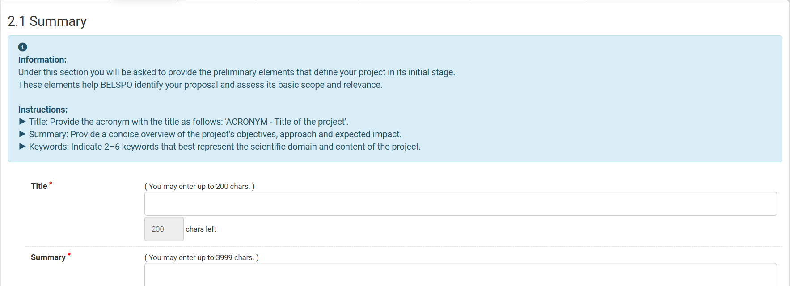
- Title: Please include the acronym with the title, respecting the following structure: ACRONYM - Full length project title. Because the applications are listed by number (application ID) and title, and titles may appear similar, this is a way for yourself and BELSPO to find your project more easily in the Platform.
- Summary: Please note that the max. extension of 3999 characters includes spaces, and that any special characters may count as more than one character. The use of bold, italic, etc is not possible.
Click on Save Draft & Continue once you have completed this part of the form, to move on to the next section.

Attention! Editable & non-editable fields
✓ Title and the summary can be modified at the level of the Full Proposal.
x Keywords cannot be modified at the level of the Full Proposal.
Modifications are allowed as long as the version of the summary in the Full Proposal does not diverge from the one entered in the Expression of Interest to the point that the expertise mobilised for the evaluation of the proposal will become irrelevant.

3.4. FILL IN SECTION 3. COORDINATOR
Section 3. Coordinator
This section cannot be modified at the level of the Full Proposal.
The Coordinator section is made of 2 questions:
  - Organisation details
  - Coordinator (Principal Investigator)

Question 3.1. Organisation details
Complete the information, regarding the department and website of the Coordinator’s organisation.
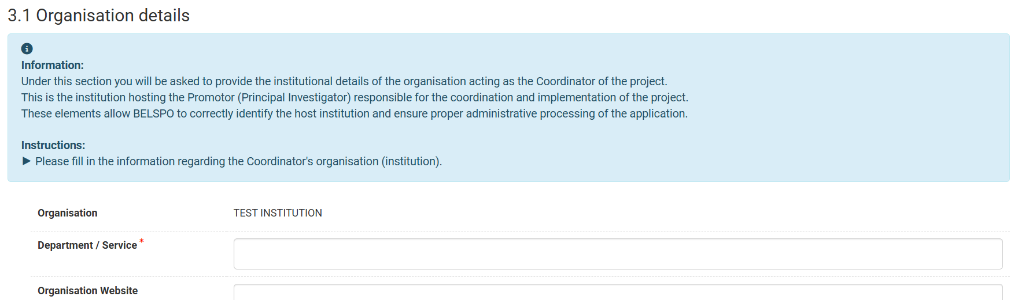

Question 3.2. Promotor (Principal Investigator)
Complete the information, regarding the Coordinator as the person responsible for the coordination of the project in their organisation.
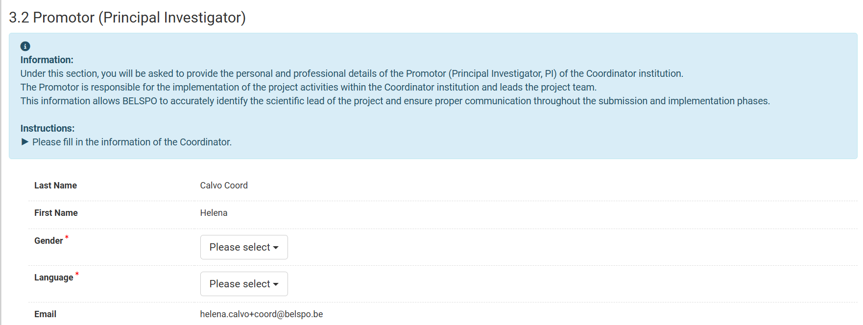
Coord@org.be
Last Name Coordinator
First Name Coordinator
Click on Save Draft & Continue once you have completed this part of the form, to move on to the next section.

Attention! Non-editable fields
Note that fields in Section 3. Coordinator cannot be modified at the level of the Full Proposal.

3.5. FILL IN SECTION 4. FUNDED PARTNER(S) INFORMATION
Skip this section if you do NOT have Funded Partner(s). Go to 3.5. of this manual (Fill in Section 3. Proposed Evaluators).
Section 4. Funded Partner(s)
The Funded Partner(s) form is made of a min. of 1 sub-tab and a max. of 10 sub-tabs, each corresponding to one Funded Partner:
  - Partner information 1
  - Partner information 2
  - Partner information 3…

Only the first tab is visible, in order to add more Funded Partners, you must click on +Add Partner Information at the bottom of the page.

Questions
Under each sub-tab, there are two questions:
4.1.1. Organisation details
4.1.2. Promotor (Principal Investigator)

Question 4.1. Partner Information 1 > 4.1.1 Organisation details
Under 4.1.1 Organisation details, the Coordinator must enter the information of the organisation of the first Funded Partner. Note that Coordinator must not enter their own information as Funded Partner here.
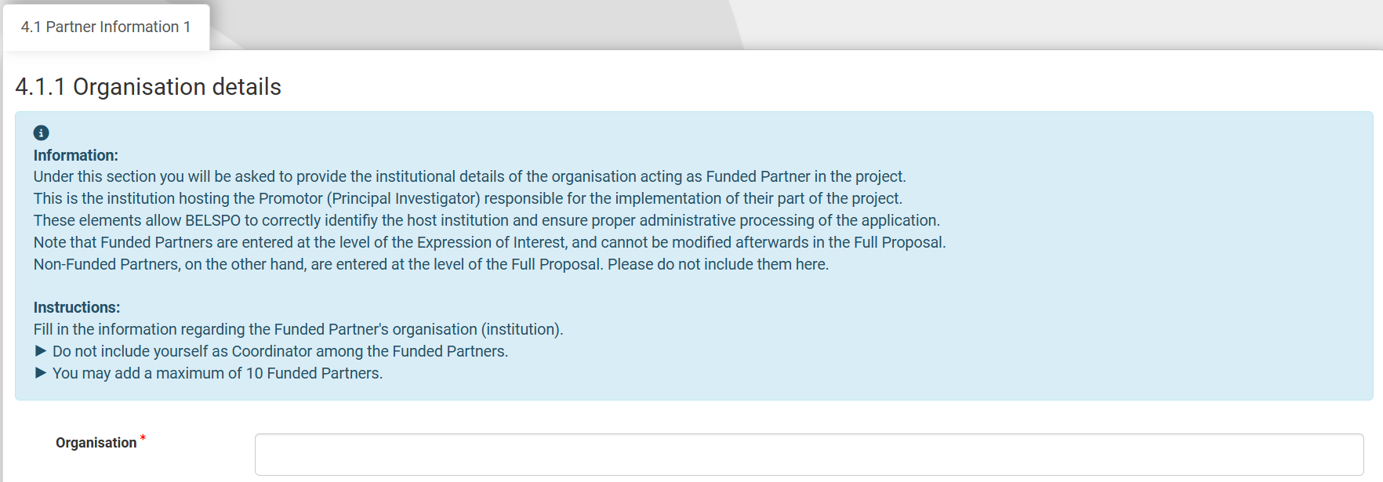

Question 4.1. Partner Information 1 > 4.1.2 Promotor (Principal Investigator)
Under 4.1.1 Organisation details, the Coordinator must enter the information of the promotor (Principal Investigator), which is the person responsible for the implementation of the project in the Funded Partner organisation.
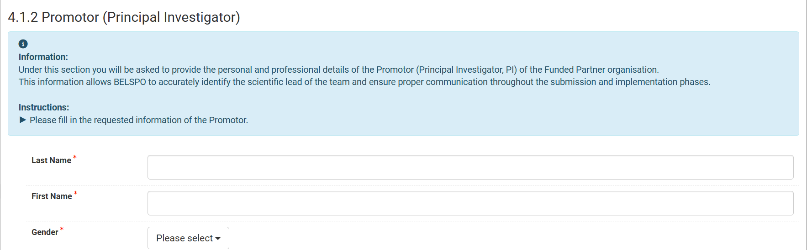
Once the first Funded Partner has been entered, at the bottom of the page:
- Click on + Add Partner information on the left of the form to add another Funded Partner.
- Click on Save Draft & continue in the middle of the form to move on to the next section.

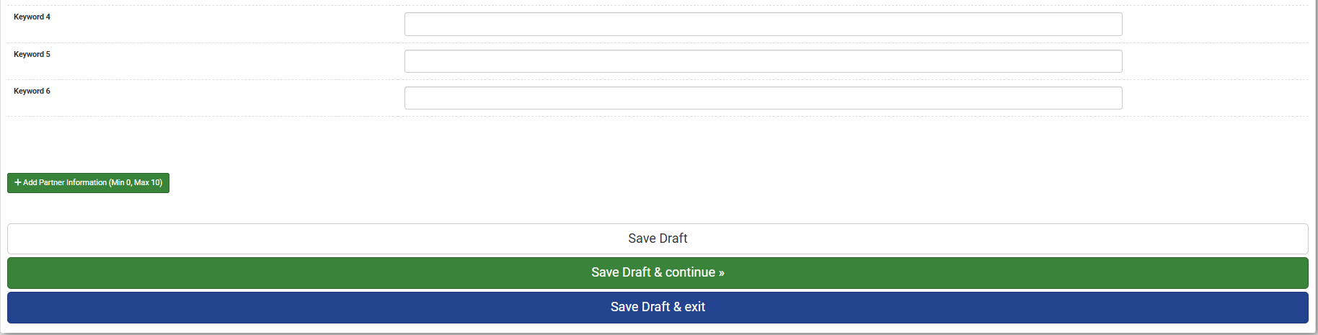
GO TO NEXT SECTION
ADD ANOTHER
PARTNER

Attention! Non-editable fields
Note that fields in Section 4. Funded Partner(s) Coordinator cannot be modified at the level of the Full Proposal.

Question 4.2. Partner Information 2 > 4.2.1 Funded Partner
Skip this section if you do NOT have more Funded Partner(s). Go to 3.5. of this manual (Fill in Section 3. Proposed Evaluators).
If you have clicked on + Add Partner Information, you will see a new sub-tab appear: 4.2. Partner Information 2. You can navigate these sub-tabs by clicking on them.
Enter the information of the second Funded Partner.
Once the information of the second Funded Partner has been entered:
- Click on + Add Partner information at the bottom of the form to add another Funded Partner.
- Click on Save Draft & continue at the bottom of the form to move on to the next section.

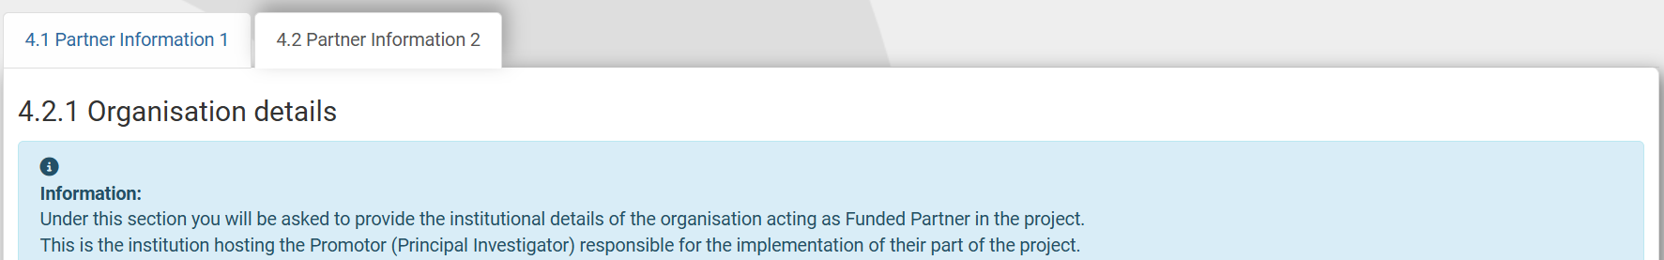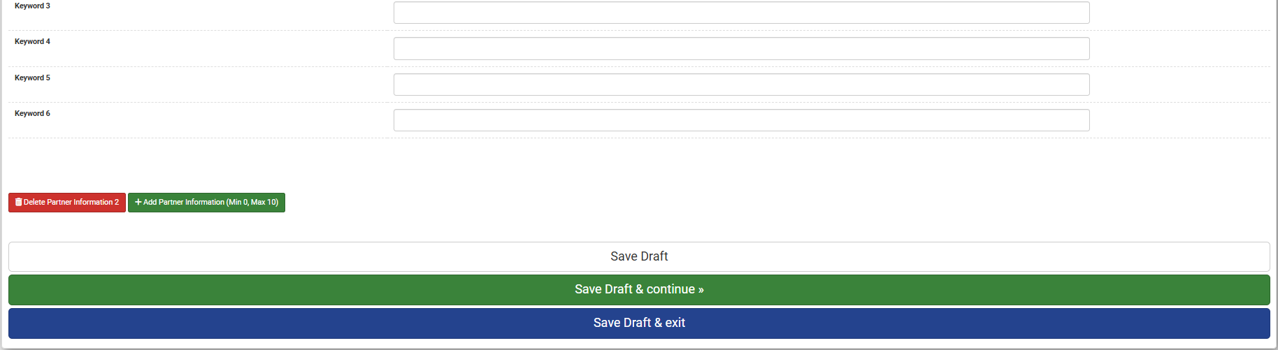
ADD FUNDED
PARTNER
GO TO NEXT SECTION
THERE ARE 2 TABS NOW, ONE FOR EACH FUNDED PARTNER
Repeat + Add Partner Information until you have entered all Funded Partners needed for your application. Note that the max. number of Funded Partners that can be added is 10.

Edit or delete Funded Partners in the Expression of Interest
You may edit the information provided for the Funded Partners at any time before you submit the Expression of Interest.
You may also delete the entire Funded Partner by clicking on Delete Partner Information X.
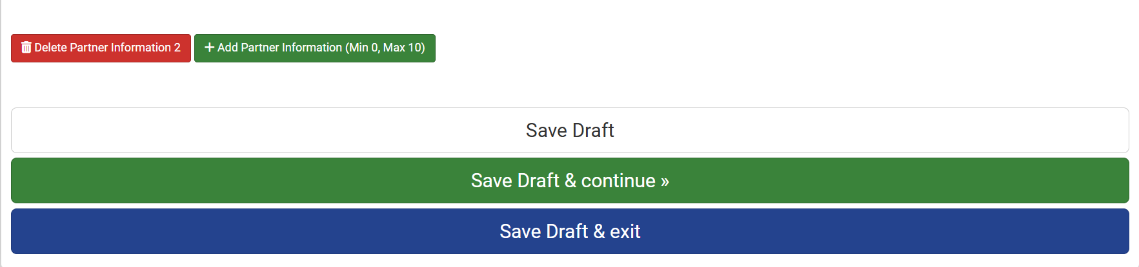
DELETE FUNDED
PARTNER

Note that this works only for Funded Partners other than the first one. The only way to delete the first Funded Partner is to state that there are NO Funded Partners for this application.
To delete Funded Partner 1, you need to go back to 3.2. Fill in Section 1. Of this manual (General Information – Question 1.3. Optional sections in the Expression of Interest form), and answer NO to the question: Does your project contain Funded Partners?

Attention! Submission is impossible with uncompleted fields in Funded Partners’ section.
If you have created an ‘extra’ Funded Partner tab that you have left blank, the system will state that there is an error, and will not allow you to submit the form. You must delete the extra tab to be able to submit the form.

3.6. FILL IN SECTION 5. PROPOSED EVALUATORS
IT IS MANDATORY TO PROVIDE 4 PROPOSED EVALUATORS
A proposed evaluator is an evaluator suggested by the applicants to review the quality, feasibility and potential impact of their Full Proposal. Proposed evaluators must be free of conflict of interest. BELSPO may use proposed evaluators to compose the team of reviewers that will perform the individual evaluation or your Full Proposal.

Section 5. Proposed Evaluators
The Proposed Evaluators section is made min. 4 and max. 6 sub-tabs, each corresponding to one proposed evaluator:
  - Proposed Evaluator 1
  - Proposed Evaluator 2
  - Proposed Evaluator 3…

Only the first tab is visible, in order to add more Proposed Evaluators, you must click on +Add Proposed Evaluators at the bottom of the page.

Questions
Under each sub-tab, there is one question. Example: 3.1 Proposed Evaluators 1
3.1.1 Proposed Evaluators

Question 5.1. Proposed Evaluators 1 > 5.1.1 Proposed Evaluators
Under 5.1.1 Proposed Evaluators, the Coordinator must enter the information of the first Proposed Evaluator.
Once the information of the first Proposed Evaluator has been entered, you must create a new sub-tabs to include a second Proposed Evaluator. It is mandatory to include 4 Proposed Evaluators in your Expression of Interest, but you may add up to 6 Proposed Evaluators.
Click on + Add Proposed Evaluator at the bottom of the form to add a sub-tab for a new Proposed Evaluator.
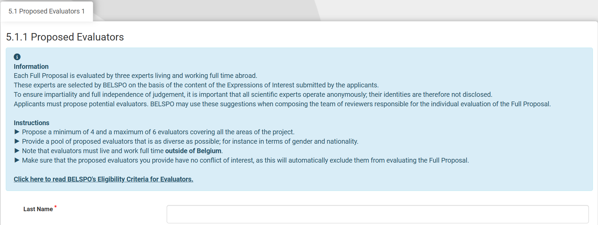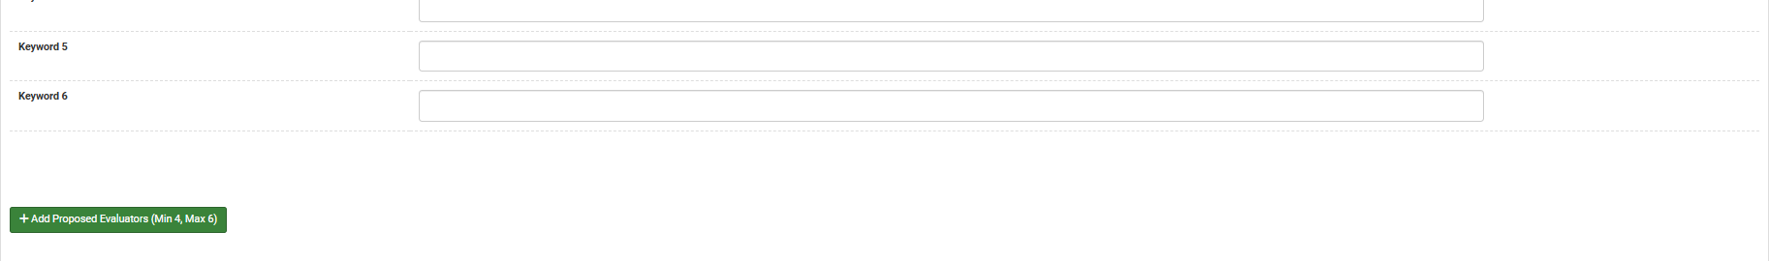
ADD PROPOSED EVALUATOR

Question 5.2. Proposed Evaluators 2 > 5.2.1 Proposed Evaluators
Under 5.2.1 Proposed Evaluators, the Coordinator must enter the information of the second Proposed Evaluator.
Once the information of the second Proposed Evaluator has been entered, you must create another new sub-tab to include a third Proposed Evaluator:
- Click on + Add Proposed Evaluator at the bottom of the form to add a sub-tab for a new Proposed Evaluator. You must add a minimum of 4 Proposed Evaluators.
- Click on Save Draft & continue at the bottom of the form to move on to the next section.

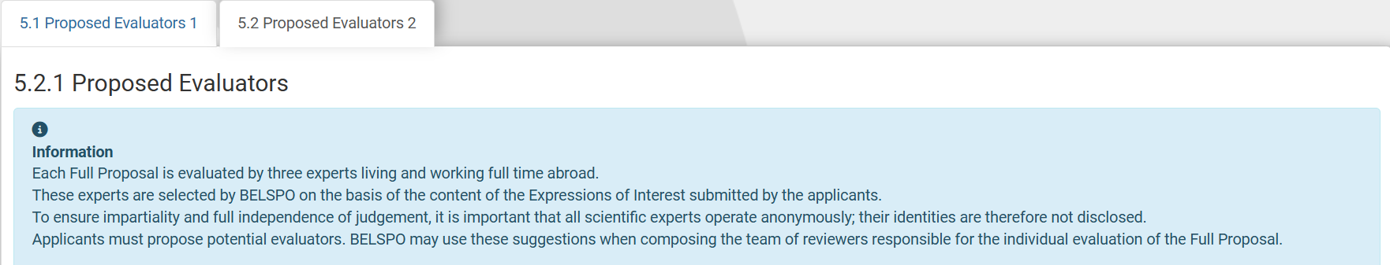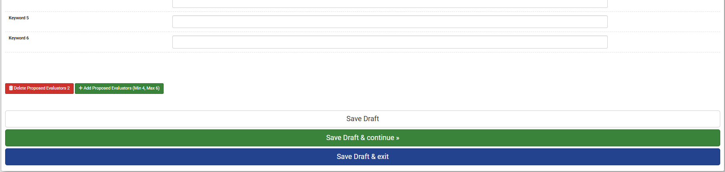
GO TO NEXT SECTION
ADD PROPOSED EVALUATOR
Repeat + Add Proposed Evaluator until you have included at least 4 Proposed Evaluators in your Expression of Interest. You can enter a maximum of 6 Proposed Evaluators.

Edit or delete Proposed Evaluators
You may edit the information provided for the Proposed Evaluators any time before you submit the Expression of Interest.
You may also delete the entire Proposed Evaluator, by clicking on the Delete Proposed Evaluator button.
DELETE
PROPOSED EVALUATOR
Note that you must introduce at least 4 Proposed Evaluators, and that since Proposed Evaluators are mandatory, you cannot delete all of the sub-tabs – the sub-tab for Proposed Evaluator 1 will remain.

Attention! Submission is impossible with uncompleted fields in Funded Partners’ section.
Note that if you have created an ‘extra’ Proposed Evaluator tab that you have left deliberately blank, the system will state that there is an error. You must delete the extra tab to be able to submit the form.

3.7. FILL IN SECTION 6. NON-GRATA EVALUATORS
Skip, if you do not want to provide Non-Grata Evaluators. Go to 3.8. of this manual (Sumit Expression of Interest).
IT IS OPTIONAL TO PROVIDE NON-GRATA EVALUAATORS
A Non-Grata Evaluator is an evaluator that applicants exclude from reviewing their Full Proposal. BELSPO will not choose this person to evaluate the Full Proposal.
Section 6. Non-Grata Evaluators
The Non-Grata Evaluators section is made min. 1 and max. 2 sub-tabs, each corresponding to one Non-Grata evaluator:
  - Non-Grata Evaluator 1
  - Non-Grata Evaluator 2

Only the first tab is visible, in order to add more Non-Grata Evaluators, you must click on +Add Non-Grata Evaluators at the bottom of the page.

Questions
Under each sub-tab, there is one question. Example: 4.1 Non-Grata Evaluators 1
4.1.1 Non-Grata Evaluators

Question 6.1. Non-Grata Evaluators 1 > 6.1.1 Non-Grata Evaluators
Under 6.1.1 Non-Grata Evaluators, the Coordinator can enter the information of the first Non-Grata Evaluator.
Once the information of the first Non-Grata Evaluator has been entered, the Coordinator can create a new sub-tab to include a second Non-Grata Evaluator. You may add a total of 2 Non-Grata Evaluators.
Click on + Add Non-Grata Evaluator at the bottom of the form to add a sub-tab for a new Non-Grata Evaluator.
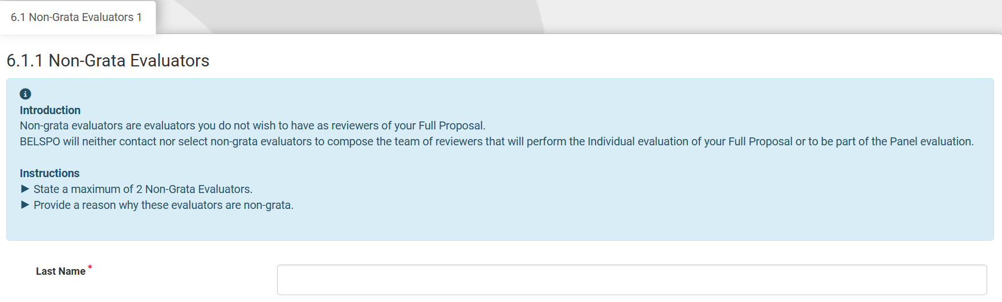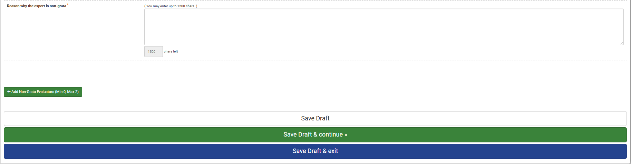
ADD NON-GRATA EVALUATOR

Question 6.2 Non-Grata Evaluators 2 > 6.2.1 Non-Grata Evaluators
Skip, if you do not want to include a second Non-Grata Evaluator. Go to Section 3.8. (of this manual) Sumit Expression of Interest.
If you have clicked on + Add Non-Grata Evaluator, you will see a new sub-tab appear: 6.2. Non Grata Evaluators 2. You can navigate these sub-tabs by clicking on them.
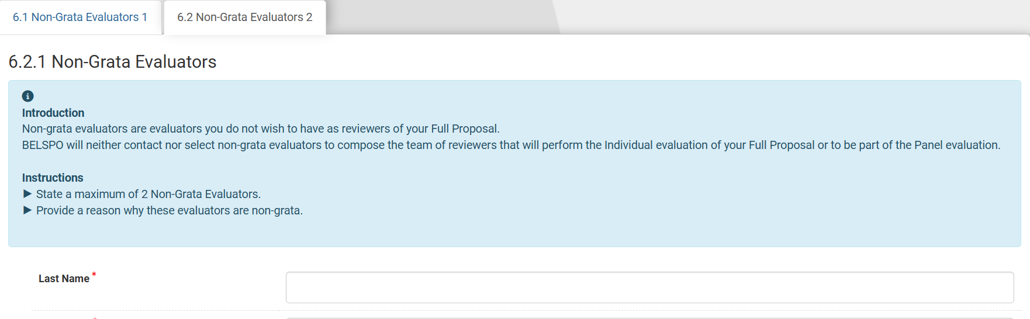
Under 6.2.1 Non-Grata Evaluators, the Coordinator can enter the information of the second Non-Grata Evaluator.
Click on Save Draft & Continue to proceed to the next section.

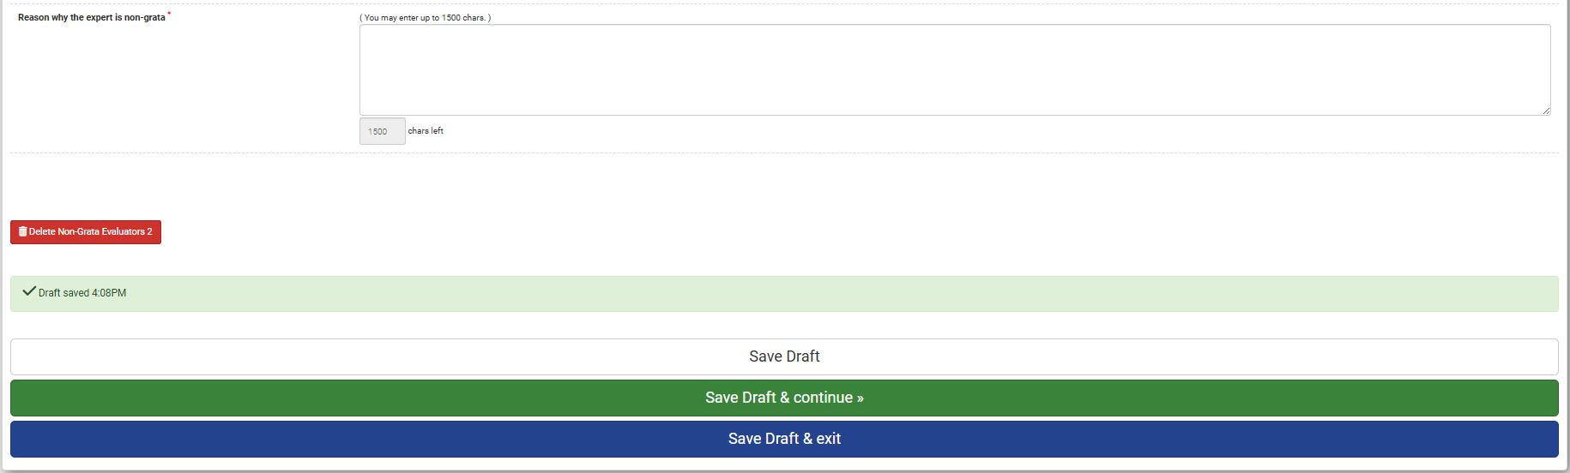

Edit or delete Non-Grata Evaluators
You may edit the information provided for the Non-Grata Evaluators any time before you submit the Expression of Interest.
You may also delete the entire Non-Grata Evaluator, by clicking on Delete Non-Grata Evaluator button.
DELETE
NON-GRATA EVALUATOR
Note that this works only for the second Non-Grata evaluator. The only way to delete the first Non-Grata Evaluator is to state that there are NO Non-Grata Evaluators for this application.
To delete Non-Grata Evaluator 1, you need to go back to 3.2. Fill in Section 1 of this manual (General Information – Question 1.3. Optional sections in the Expression of Interest form), and answer NO to the question: Do you wish to add Non-Grata Evaluators?

Attention! Submission is impossible with uncompleted fields in Non-Grata Evaluators section.
Note that if you have created an ‘extra’ Non-Grata Evaluator tab that you have left blank, the system will state that there is an error. You must delete the extra tab to be able to submit the form.

3.8. SUBMIT EXPRESSION OF INTEREST
submission of an Expression of Interest is irreversible. Expressions of Interest cannot be modified or withdrawn after submission.
Once you have completed all the sections, you can submit the Expression of Interest.
Wherever you find yourself in the Expression of Interest form, go to the bottom of the page.
Click on Save Draft & Exit
If you have successfully completed all required sections, the following screen will appear:
- Click on Yes, submit entire form now! If you are sure you want to submit. Note that the submission cannot be undone.
- Click on No, enter more details first, if you want to keep editing the Expression of Interest.
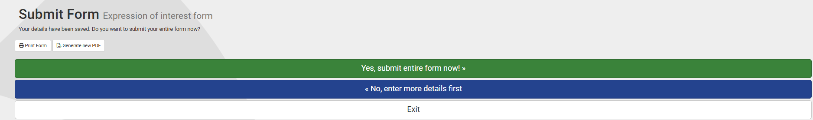
By clicking on Yes, submit entire form now! The Expression of Interest will be submitted and you will be back in your Dashboard.

Attention! Submission will FAIL…
- If you leave empty any required fields, marked with *
- If you have fewer than 4 proposed evaluators
- If you leave empty partner / evaluator tabs
The following message will appear:
‘There appears to be problems with some of your answers. Click on the question or section numbers in the errors below to go straight to the problem. You cannot submit the form until all problems are corrected’.
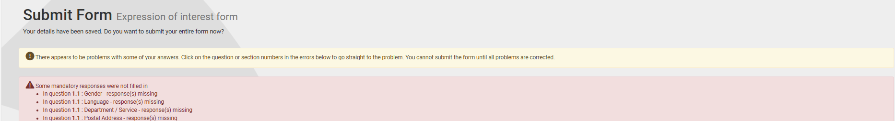
Each incomplete answer will be noted.
By passing the mouse over the number of the number of the question, the Platform will take you to the section where the information is missing.
Complete the missing information.
Click on Save Draft & Exit.

4. Access (and edit) your Expression of Interest in the Platform

BEFORE YOU HAVE SUBMITTED THE EXPRESSION OF INTEREST
If you save your progress but do not submit your Expression of Interest, you will find the application on your Dashboard in two places:

Under Upcoming Tasks:
Upcoming tasks lists all the applications for which you have tasks to accomplish in the BELSPO Platform.
Click on Continue Expression of Interest to get back to the Expression of Interest form of your application. Once there, you can edit the information and save and/or submit the Expression of Interest.
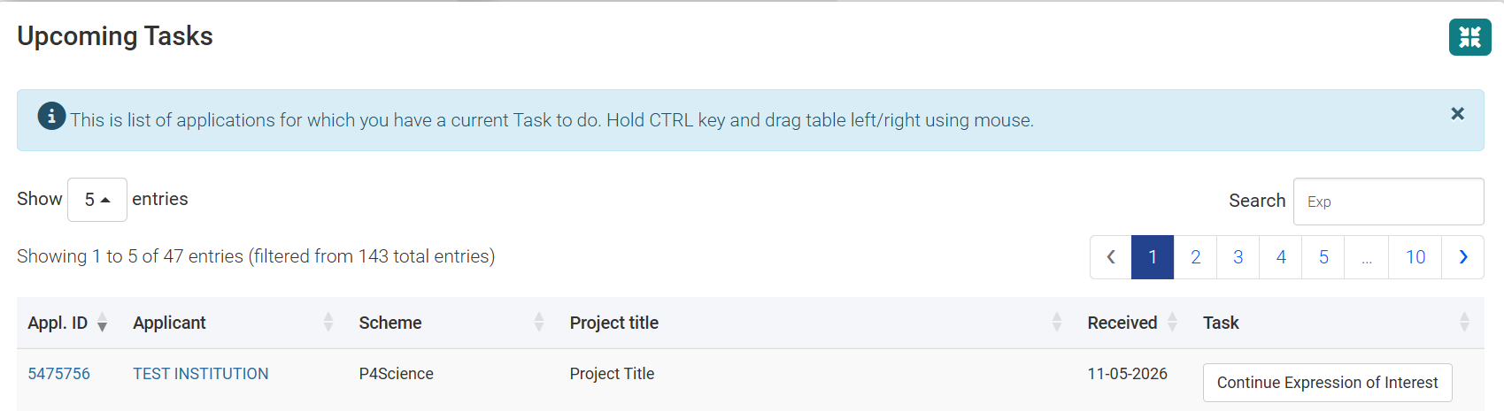
Information under Upcoming Tasks:
- Appl. ID : Is the unique identifier of your application in the BELSPO Platform. This hyperlink will not show anything until you have submitted the Expression of Interest.
- Applicant: This is the institution to which you are linked for this application.
- Scheme: This is the programme you are applying to.
- Project title: This is the title of your application. It states ‘Project Title’ as long as you have not submitted the Expression of Interest.
- Received: This is the date you have received a task in the system in regards to this application. In this case, while the Expression of Interest is not submitted, your task is to submit the Expression of Interest.
- Task: This is the task that you have to do on the platform.

Under My Applications:
My applications lists all applications you are coordinating.
Again, there is an hyperlink in the Application ID of your application, but as long as you have not submitted the Expression of Interest it will show nothing.
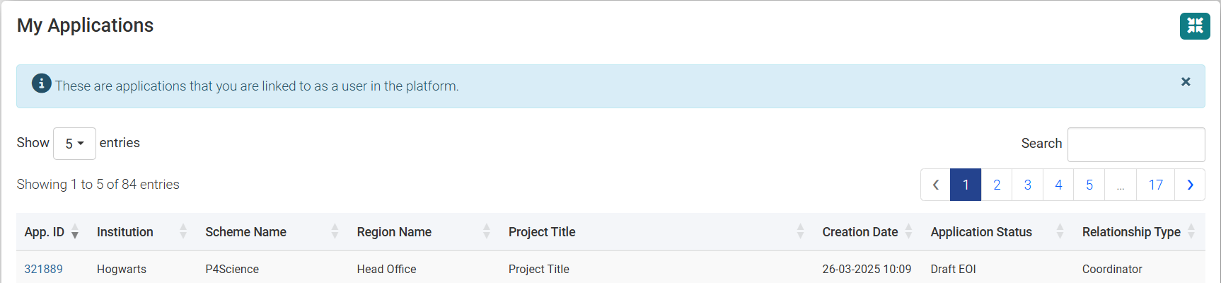
TEST INSTITUTION
- Appl. ID : Is the unique identifier of your application in the BELSPO Platform.
- Institution: This is the institution to which you are linked for this application.
- Scheme Name: This is the programme you are applying to.
- Region Name: By default this will always say ‘Head Office’.
- Project title: This is the title of your application. It states ‘Project Title’ as long as you have not submitted the Expression of Interest.
- Creation Date: This is the date you created the application.
- Application Status: This is the status of your Expression of Interest. As long as it is not submitted it will say ‘Draft EoI’.
- Relationship Type: This is the role that you have in this application.

AFTER YOU HAVE SUBMITTED THE EXPRESSION OF INTEREST

Under My Applications:
After submitting your Expression of Interest, you will land back on the Dashboard.
Your Expression of Interest not appear under My Upcoming Tasks list unless:
- BELSPO finds an issue while conducting the eligibility check, in which case BELSPO will contact you to revise it.
- It is time to submit your Full Proposal.
Until then, it will only be visible under My Applications.
Now, the Project Tille of your Expression of Interest will appear, and the Application Status will have changed from Draft EoI to Expression of Interest submitted.

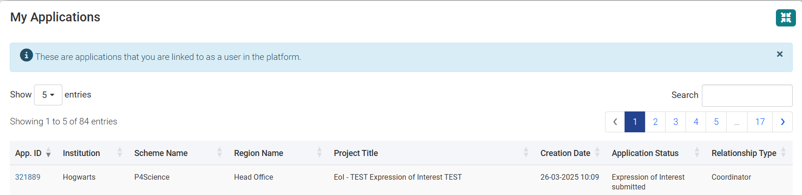
TEST INSTITUTION
Click on the Application Number hyperlink to access your Expression of Interest once you have submitted it. You will arrive to the Application page.

The Application page:
Application page
The Application page is where all the information regarding your application is kept.
There are 2 tabs in this page: Summary and Documents. The Application page opens on the Documents tab.
- Summary tab: It is the technical sheet of your application. Contains the main information. These appear under the title ‘Standard Details’.
- Documents tab: The Documents tab contains all the documents of your application. These appear under the title ‘Correspondence Log’. At this point, you will only find your Expression of Interest here.

The Documents tab
Click on Form Created Expression of Interest Form to Download the Expression of Interest in RTF form.
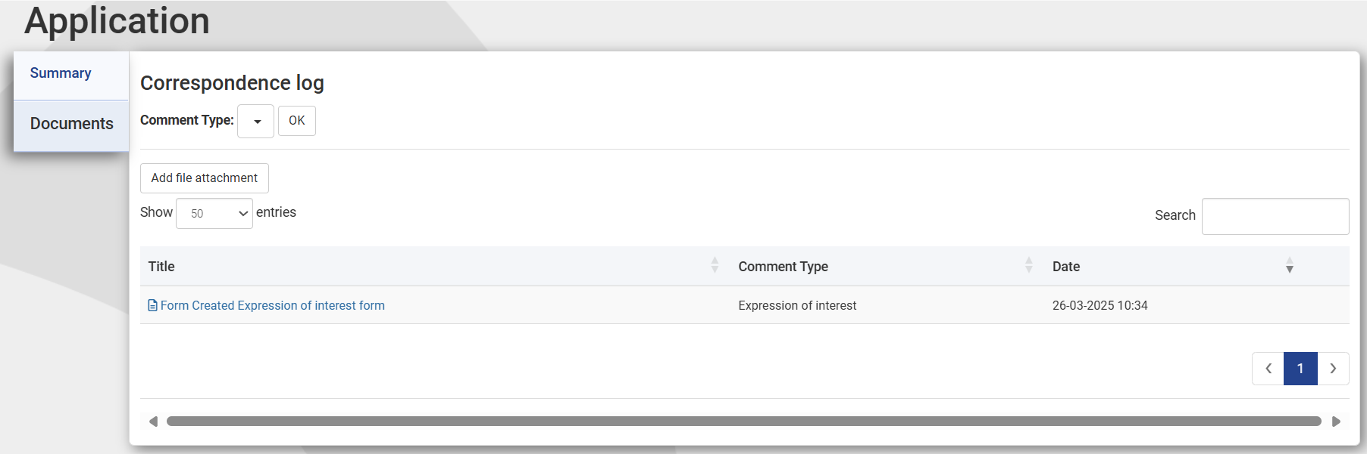

The Summary tab
Click on Summary to check the Summary tab.
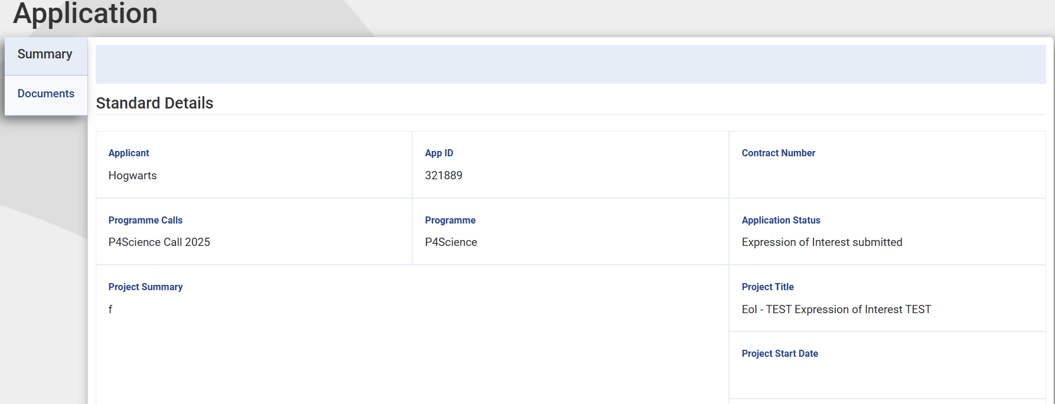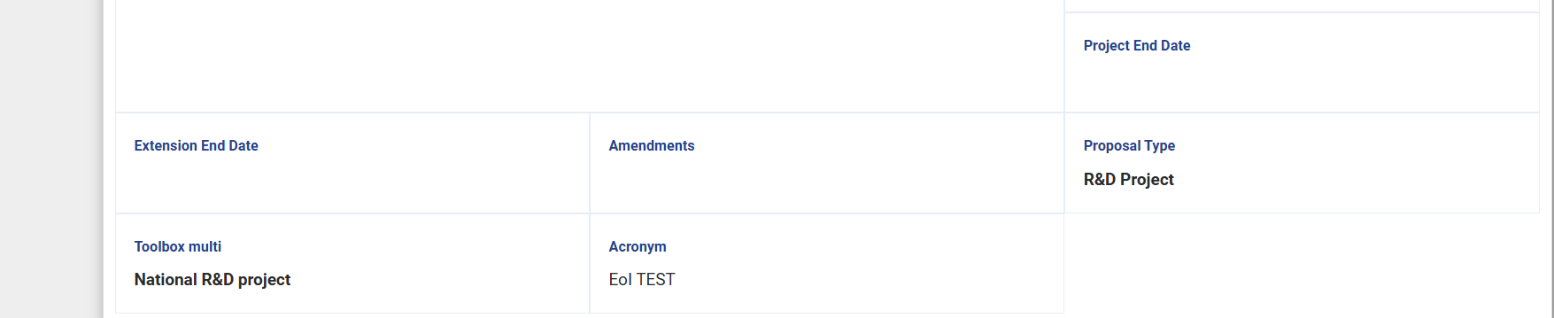
TEST INSTITUTION
Click on the Paper-tray icon on the upper left hand corner of the page to go back to the Dashboard.


Delete your Expression of Interest in the Platform
Deleting your Expression of Interest is only possible BEFORE submission.
In order to do, you must go to the Dashboard.
Click on the Paper-tray icon on the upper left hand corner of the page to go back to the Dashboard.
Scroll down to the Upcoming Tasks list.
Click on the Application Number hyperlink. You will arrive to the Application page.
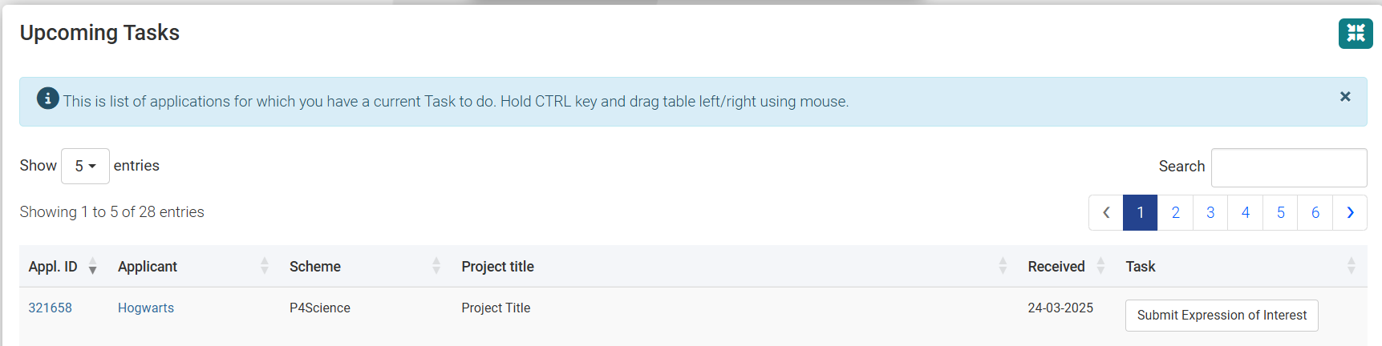
TEST INSTITUTION
Once in the Application page, click on the cancel button. This action cannot be undone.
