Full Proposal Form
Full Proposal form

1. General Information
Section / Questions / Fields marked with * are mandatory.

  - Project ID
Information:
This question has several non-editable fields where you will find the main elements that constitute the ID of your project.
Please note the Application ID number (Appl ID) and use it to refer to the project in any communication with BELSPO.
Instructions:
► Please modify - if needed - the budget of the proposal and the INCO budget.
► Note that the budget of the proposal is the TOTAL budget excluding the INCO budget.
BELSPO Programme | P4Science – As in your EoI. Not editable
Call Year | P4Science Call 2026 – As in your EoI. Not editable
Organisation of the Coordinator | TEST INSTITUTION – As in your EoI. Not editable
Coordinator | First & Last Name of Coordinator – As in your EoI. Not editable
Application ID | 5477085 – As in your EoI. Not editable
Acronym of the Proposal | ACRONYM – As in your EoI. Not editable
Duration of the Proposal (months) | 48 – As in your EoI. Not editable
Budget of the Proposal (euro)  (INCO budget not included) | 730.000€ – As in your EoI Editable
INCO Budget (euro) | 25.000€ – As in your EoI Editable

  - Project Classification

Information:
This is a non-editable question stating how your project is classified.
Research Priorities | Heritage collection: innovative methods for conservation – As in your EoI. Not editable  Ecosystems, climate & environmental health
Strategic Area of Impact | Exploration and exploitation of the Earth – As in your EoI. Not editable
Type of Project  (Toolbox Level 1) | R&D Project – As in your EoI. Not editable
Type of Project  (Toolbox Level 2) | Citizen science project – As in your EoI. Not editable  National R&D project

  - Presence of Funded and Non-Funded Partners *

Information:
This question is applicable for all project types. It concerns the presence of Funded and Non-Funded Partners.
Funded Partners were introduced in the Expression of Interest and remain the same. Non-Funded Partners are introduced in the Full Proposal for the first time.
Instructions:
► Funded Partners: The choice made at the level of the Expression of Interest appears here by default. Do not change the selection.
► Non-Funded Partners: By selecting, 'My project HAS Non-Funded Partners', the section regarding Non-Funded Partner(s) will be enabled.
► Note that if selected, the completion of the section is mandatory.
Funded Partners | YES - My project HAS Funded Partners. – MUST NOT BE CHANGED
Non-Funded Partners | ☐ YES - My project HAS Non-Funded Partners, OR  ☐ NO – My project does NOT have Non-Funded Partners.  – Depending on your choice Section 10. Non-Funded Partners will be enabled or disabled.

  - Declarations *

Information:
This question is applicable for all project types.
Instructions:
► Please read carefully the documents linked at the bottom of this box.
► Make sure that your Funded and Non-Funded Partners read the documents.
► Then, accept the mandatory declarations.
► Indicate if you have used AI in the preparation or writing of the Full Proposal.
BELSPO's privacy statement
BELSPO's Open Access Mandate
Code of Ethics for Scientific Research in Belgium.
Privacy - 1 | ☐ I confirm to have read and to have asked all the partners involved and mentioned in this project proposal to read and accept BELSPO's privacy statement.
Privacy - 2 | ☐ I give my consent to process my personal data, and I confirm to have obtained the explicit consent to process the personal data of all the persons involved and mentioned in this application, in agreement with BELSPO's privacy statement.
Permission to submit | ☐ I assure that my hierarchical authority agrees with the submission of this application.
Open Access | ☐ I ensure to respect BELSPO's Open Access Mandate for publications and research data.
Code of Ethics | ☐ I ensure to respect the Code of Ethics for Scientific Research in Belgium.
Artificial Intelligence | ☐ I declare that Artificial Intelligence has been used (to assist) in the preparation or writing of this Full Proposal.  – This declaration has no impact in the evaluation.

ATTENTION – Number of characters in text fields

- The Platform only allows PLAIN TEXT (no formatting: bold, italic, bullets from word)
- the spaces count as characters
- Beware that symbols may count as multiple characters.

2. Proposal Summary
2.1 Proposal Summary *

Information:
This question is applicable for all project types.
Here you will find the title, summary and keywords you entered in the Expression of Interest.
Only the title and the summary are editable.
Instructions:
► If you wish to, you may adapt the title and summary of your project.
► Remember that the ACRONYM must be state in the title: 'ACRONYM - Title'.
► Note that the title and summary of the project may vary to some extent, but cannot diverge to the point that the expertise mobilised for the evaluation of the proposal will become irrelevant.
Title | ACRONYM – Title of the proposal – As in your EoI. Can be changed, but acronym must be kept..
Summary | Summary of the proposal (max. 3999 characters) – As in your EoI. Can be changed, but acronym must be kept..
Keyword 1 | xxx – As in your EoI. Not editable
Keyword 2 | xxx – As in your EoI. Not editable
Keyword 3 | xxx – As in your EoI. Not editable
Keyword 4 | xxx – As in your EoI. Not editable
Keyword 5 | xxx – As in your EoI. Not editable
Keyword 6 | xxx – As in your EoI. Not editable

3. State of the Art
3.1 Description of the State of the Art *

Information:
This question applies only to proposals in the R&D Project toolbox Level 1 category.
In this question you will be asked to describe the State of the Art in relation to your project.
Instructions:
► Please describe the State of the Art in relation to your proposal.
► You may upload a maximum of two images related to the State of the Art.
► Note that you may add bibliographic references in the next question.
State of the Art
State of the Art (max. 3999 characters)
Upload Image 1 for State of the Art (optional)
Max. File Upload Size (mb): 2
Allowed File Type(s): bmp, jpg, pgm, png
Upload Image 2 for State of the Art (optional)
Max. File Upload Size (mb): 2
Allowed File Type(s): bmp, jpg, pgm, png

3.2 Bibliographic References

Information:
This question applies only to proposals in the R&D Project toolbox Level 1 category (optional).
In this question you will be asked to provide the bibliographic references used to describe the State of the Art
Instructions:
► Please provide the bibliographic references mentioned in the State of the Art.
Bibliographic References (max. 3999 characters)

4. Project Objectives
4.1 Project Objectives *
Information:
This question is applicable for all project types.
Instructions:
► Please list and explain the objectives of the project.
► If the toolbox category chosen is R&D Project, do so in relation to the state of the art (current knowledge at national and international level on the topic).
Project objectives (max. 3999 characters)

5. Methodology
5.1 Methodology *
Information:
This question is applicable for all project types.
Here you will be asked to describe how the project will be implemented, the Work Packages and Tasks.
Instructions:
► Provide a detailed description of the methodology to achieve the foreseen results considering the different disciplines mobilised.
► Mention used methods, techniques, systems and/or way of working.
► Number, name and describe the work packages and tasks as in Section 6, Question 6.1.Gantt Chart.
► Please limit your answers to 36 000 characters.
► You may upload a maximum of four images.
Mandatory Work Packages:
(Replace X, Y, Z, with sequential numbers as for the other work packages).
► WP X: Coordination (mandatory for all project types).
► WP Y: Data Management (mandatory for R&D Projects - toolbox Level 1 category)
Do not forget to include a deliverable labelled Data Management Plan in month 6 at the latest.
► WP Z : Valorisation (mandatory for all project types, except Capacity Development - toolbox Level 1 category).
Methodology
Methodology (Though the platform states there is an unlimited number of characters, you are allowed to enter a max. of 36.000)
Upload Image 1 for Methodology (optional)
Max. File Upload Size (mb): 2
Allowed File Type(s): bmp, jpg, pgm, png
Upload Image 2 for Methodology (optional)
Max. File Upload Size (mb): 2
Allowed File Type(s): bmp, jpg, pgm, png
Upload Image 3 for Methodology (optional)
Max. File Upload Size (mb): 2
Allowed File Type(s): bmp, jpg, pgm, png
Upload Image 4 for Methodology (optional)
Max. File Upload Size (mb): 2
Allowed File Type(s): bmp, jpg, pgm, png

5.2 INCO Activities *
Information:
This question is applicable for all project types.
INCO activities are activities financed through the budget of the Federal, inter-federal and international coordination service of BELSPO. This is an additional complementary envelope providing seed money to support extra-European networking and extra-European international cooperation up to 30 000€/project proposal.
The funding covers travels to and from the extra-European country related to the INCO networking purposes for the Belgian FSI team(s) (and the foreign team(s), if necessary), and/or the organisation of workshops to support international networking. INCO does not cover field work campaigns. More information can be found in the Information File of the P4Science call.
Instructions:
► Please indicate whether your project includes INCO activities.
► If your project includes INCO activities, please specify.
INCO activities | YES – My project INCLUDES INCO activities, OR  NO – My project does NOT include INCO activities.
If your answer is YES – Please complete  INCO Budget declaration | ☐ I have added the INCO budget in Section 1. General Information - Question 1.1. Application ID, of this form.
If your answer is YES – Please complete  Describe the INCO activities included in your project. | INCO activities description (max. 2000 characters)

6. Gantt Chart & Risk Management
6.1 Gantt Chart *
Information:
This question is applicable for all project types.
Here you will be asked to complete the Gantt chart template, available linked here and in the P4Science website.
Instructions:
► Please download the Gantt Chart template, complete it and upload it to the platform.
Mandatory Work Packages:
(Replace X, Y, Z, with sequential numbers as for the other work packages).
► WP X: Coordination (mandatory for all project types).
► WP Y: Data Management (mandatory for R&D Projects - toolbox Level 1 category)
Do not forget to include a deliverable labelled Data Management Plan in month 6 at the latest.
► WP Z : Valorisation (mandatory for all project types, except Capacity Development - toolbox Level 1 category).
Click here to download the Gantt Chart.
Upload Gantt Chart File
Max File Upload Size (mb): 20
Allowed File Type(s): xls, xlsx

6.2 List of Risks Related to the Implementation of the Project *
Information:
This question is applicable for all project types.
In this question, you will be required to list the risk associated with the implementation of the project and classify them.
Instructions:
► Please enter the risks associated to the implementation of the project in relation to the tasks.
► Number the risks following the number of the tasks.
► Signal the likelihood of the risk (probability that it may occur), and its importance.
► Add as many lines as needed to cover the risks that could delay or hinder the project.
Attention!
► Click on +Add Item to list to save each entry. Otherwise the entry will not be retained by the system.
► To delete a risk use the Delete button next to it.
Number of the task  in the Gantt chart  related to the risk | Title of the risk | Likelihood of the risk | Importance of the risk
T.X.X. | Title of the risk in relation to task X.X | ☐ Very Unlikely  ☐ Unlikely  ☐ Possible  ☐ Likely  ☐ Very Likely | ☐ Negligible  ☐ Minor  ☐ Moderate  ☐ Significant  ☐ Sever

6.3 Contingency Plan for the Risks Mentioned Above *
Information:
This question is applicable for all project types.
In this question, you will be required to explain the risks listed above.
Instructions:
► Please explain the risks associated to the implementation of the project in relation to the tasks.
► Mention the specific contingency plan for each of the risk mentioned above.
Contingency plan (max. 3999 characters)

7. Data Management Plan
7.1 Data Management Plan Declarations *
Information:
This question only applies to proposals in the R&D Project toolbox Level 1 category.
The Data Management Plan requested in this section as part of the Full Proposal a simplified / abridged version of the document that must be produced if the project proposal is selected for funding.
Instructions:
► Read and approve the declarations.
► Remember to include Data Management Plan deliverable in the Gantt Chart.
DMP document | ☐ I understand that if this project proposal is selected for funding, a comprehensive Data Management Plan will have to be completed and handed in to BELSPO within the first 6 months from the official starting date of the project.
DMP deliverable | ☐ I have included a DMP deliverable in month 6 (at the latest) in the Gantt Chart that is part of this project proposal.

7.2 Data Summary *
Information:
This question only applies to proposals in the R&D Project toolbox Level 1 category.
You will be asked here about the data that will be used in the project
Instructions:
► Please provide information regarding the type(s) of data that will be used in the project (experimental, observational, images, text…).
► Explain if/how the data will be collected and/or if existing data will be reused.
► Mention the origins of the data (source of collected and/or re-used datasets).
► Include the estimated size of the data, how it will be collected and or/ re-use of existing data.
Data Summary (max. 3999 characters)

7.3 Open and FAIR Compliance *
Information:
This question only applies to proposals in the R&D Project toolbox Level 1 category.
You will be asked here about the Open and FAIR compliance of the data that will be used in the project
Instructions:
► Please provide information regarding the Open and FAIR management of data.
► List the identifiers or repositories that will be used.
► Mention the information that will be made available on Open Access, as well as access provisions and IPR arrangement where relevant.
► Provide information on standards, formats and vocabularies for data and metadata that will be used to make data interoperable.
► State the licensing for data sharing and tools/software/models for data generation and validation/interpretation/re-use to ensure the re-usability of the data.
OPEN and FAIR Compliance (max. 3999 characters)

7.4 Curation, Storage and Preservation Costs *
Information:
This question only applies to proposals in the R&D Project toolbox Level 1 category.
You will be asked here about the curation, storage and preservation costs of the data that will be used in the project
Instructions:
► Please provide information regarding the curation, storage and preservation costs of data.
► Explain who will be the person/entity/team that will be responsible for data management and quality assurance.
Curation, Storage and Preservation Costs (max. 3999 characters)

8. Coordinator
8.1 Coordinator: Organisation Details *
Organisation | TEST INSTITUTION – As in your EoI. Not editable
Department / Service | Department of TEST INSTITUTION – As in your EoI. Not editable
Website of the organisation | Website of the organization – As in your EoI. Not editable

8.2 Coordinator: Promotor ( = Principal Investigator ) *
Information:
This question is applicable for all project types.
Under this section you will be asked to provide professional information of the Promotor (Principal Investigator, PI).
Note that some of the fields are already completed with the information you entered in the Expression of Interest.
Instructions:
► Please enter the requested information of the Promotor.
Last Name | Last Name Coordinator – As in your EoI. Not editable
First Name | First Name Coordinator – As in your EoI. Not editable
Gender | Female – As in your EoI. Not editable
Discipline 1 | Discipline 1 – As in your EoI. Not editable
Discipline 2 | Discipline 2 – As in your EoI. Not editable
Number of years  active in research | Enter number
Number of years of  management experience | Enter number
Professional background and relevant experience in relation to the project, including managerial experience | Professional background of the investigator (not of their team!) (max. 3999 characters)

8.3 Coordinator: Team
Information
This question is applicable for all project types.
Completion of this question is optional. Where the Coordinator involves a team composed of more than one individual, applicants may provide this information.
Under this question you may provide professional information of the Coordinator's team.
This refers to staff belonging to the same institution of the Coordinator (or to be hired within the same institution) that will be working for the project.
Instructions:
► Please enter relevant professional information of the Coordinator's team.
► Mention only persons that are named in the Budget table, under the Coordinator's Staff budget.
► Include both staff paid by the project, and working in kind for the project.
Coordinator: Team (max. 3999 characters)

8.4 Coordinator: Top Achievements, Milestones, (Peer-reviewed) Publications and Projects.
Information:
This section is applicable for all project types.
You will be required to provide top achievements, milestones, (peer-reviewed) publications and projects in which the Coordinator and their team have participated.
These need to be relevant to the project proposal.
Instructions:
For the Coordinator and their team:
► Please provide a list of maximum of 5 relevant top achievements, milestones, and (peer-reviewed) publications achieved over the past 5 years.
► Provide a list of maximum of 5 relevant projects, with details: Acronym, weblink, duration in months, funding source and role (Coordinator or Partner).
Coordinator: Top Achievements (max. 3999 characters)

9. Funded Partner(s)
This section only appears if you have answered YES to the question regarding the presence of Funded Partners in the Expression of Interest. Do NOT add or delete Funded Partners.
9.1.1 Funded Partner 1 - Funded Partner: Organisation details *
Information:
This is a non-editable question containing information of the Funded Partner's organisation that you entered in the Expression of Interest.
This question appears because you have ticked the Funded Partner statement in section 1. General Information of the Full Proposal.
Organisation | Funded Partner 1 organisation – As in your EoI. Not editable
Department / Service | Funded Partner 1 department – As in your EoI. Not editable
Website of the organisation | Funded Partner 1 website – As in your EoI. Not editable

9.1.2 Funded Partner 1 - Funded Partner : Promotor ( = Principal Investigator ) *
Information:
This question is applicable for all project types.
Under this section you will be asked to provide professional information of the Promotor (Principal Investigator, PI)
Note that some of the fields are already completed with the information you entered in the Expression of Interest. Do not change the entered information.
Instructions:
► Please enter the requested information of the Promotor.
Last Name | Funded ¨Partner 1 Last Name – As in your EoI. Not editable
First Name | Funded Partner 1 First Name – As in your EoI. Not editable
Gender | Female – As in your EoI. Not editable
Discipline 1 | Discipline 1 – As in your EoI. Not editable
Discipline 2 | Discipline 2 – As in your EoI. Not editable
Number of years active in research | Enter number
Number of years ofmanagement experience | Enter number
Professional background and relevant experience in relation to the project, including managerial experience | Professional background of the investigator (not of their team!) (max. 3999 characters)

9.1.3 Funded Partner 1 - Funded Partner: Team
Information:
This question is applicable for all project types.
Completion of this question is optional. Where the Funded Partner involves a team composed of more than one individual, applicants may provide this information.
Under this question you may provide professional information of the Funded Partner's team.
This refers to staff belonging to the same institution of the Funded Partner (or to be hired within the same institution) that will be working for the project.
Instructions:
► Please enter relevant professional information of the Funded Partner's team.
► Mention only persons named in the Budget table, under the Funded Partner's Staff budget.
► Include both staff paid by the project, and working in kind for the project.
Funded Partner 1: Team (max. 3999 characters)

9.1.4 Funded Partner 1 - Funded Partner: Top achievements, milestones or (peer-reviewed) publications related to the project *
Information:
This question is applicable for all project types.
You will be required to provide top achivements, milestones, (peer-reviewed) publications and projects in which the Funded Partner and their team have participated.
These need to be relevant to the project proposal.
Instructions:
For the Funded Partner and their team:
► Please provide a list of maximum of 5 relevant top achievements, milestones, and (peer-reviewed) publications achieved over the past 5 years.
► Provide a list of maximum of 5 relevant projects, with details: Acronym, weblink, duration in months, funding source and role (Coordinator or Partner).
Funded Partner 1: Top Achievements (max. 3999 characters)

10. Non Funded Partner(s)
This section only appears if you have answered YES to the question regarding the presence of Non-Funded Partners
You may add up to 10 Non-Funded Partners to the Full Proposal.
10.1.1 Non Funded Partner 1 - Non-Funded partners *
Introduction:
This question is applicable for all project types.
Non-Funded Partners provide substantial contributions to the project (in-kind and/or with cash), and appear in the Gantt Chart, performing tasks.
Staff providing P-M in kind, listed under the Staff costs of the Coordinator in the Budget Table, are not considered Non-Funded Partners, but part of the Coordinator's team. Please do not add them here.
Note: Federal departments and/or organisations in their capacity of service providers to the Federal Government cannot be Non-Funded Partners of a project.
Instructions:
► Please provide general personal and professional details of the Non-Funded Partner.
► Explain the professional background of the Non-Funded Partner that is relevant to the project.
► Describe the aspects of the project that are of interest to the Non-Funded Partner, and their motivation to participate in the project.
► Describe the type of contribution cash, in kind, or both, of the Non-Funded Partner to the project.
Last name | Enter last name
First Name | Enter first name
Gender | ☐ M  ☐ F  ☐ X  ☐ Not disclosed
Organisation | Enter organization
Department / Service | Enter department
Professional background relevant to the project | Professional background (max. 2000 characters)
Type of contribution  in kind / cash | ☐ In kind  ☐ Cash  ☐ Both in-kind and cash
Description of the contribution to the project (in-kind and/or in cash) | Description of the contribution (max. 3999 characters)

11. Partnership
11.1 Combined Expertise of the Consortium (Coordinator, Funded and/or Non-Funded partners) *
Information:
This question is applicable for all project types that have Funded and/or Non-Funded Partners.
Here you will be required to describe how all project partners work together in the project.
Instructions:
► Please describe how all project partners will provide the scientific expertise needed for the project.
► Specify the added value associated to addressing the research topic as a network of researchers.
Combined expertise of the consortium (max. 3999 characters).

12. Budget
12.1 Budget of the Project *
Information:
This question is applicable for all project project types.
Here you will be requested to provide the budget of your project proposal.
Instructions:
► Please download, complete and upload the Budget table template linked here below.
► This template can also be found in the P4Science website.
► Follow the budget rules provided in the document.
► Please do not delete the formulas in the template.
Click here to download the Budget table
Max File Upload Size (mb): 3
Allowed File Type(s): xls, xlsx

13. Dissemination Plan
13.1 Description of the Dissemination Plan *
Information:
This question only applies to proposals in the R&D Project toolbox Level 1 category.
Here you will be requested to describe the dissemination plan of your project, based on the deliverables marked as 'dissemination' in the Gantt Chart.
Instructions:
► Please refer to all the deliverables marked as 'dissemination' in the Gantt Chart.
► Describe, for each targeted group, how and in what form the dissemination plan is to be implemented.
► State the dissemination dates in which the deliverables marked as 'dissemination' will be made available to the foreseen public.
► Note that the dissemination date, may differ from the production date of the deliverable.
Dissemination plan (max. 3999 characters)

14. Follow-up Committee
14.1 List of potential Follow-up committee members *
Information:
This question applies only to proposals in the R&D Project toolbox Level 1 category.
In this question you will be asked to provide the details of foreseen members of your Follow-up Committee.
The Follow-up Committee is a group of individuals from various sectors, representing different interests and perspectives related to the project.
The purpose of this committee is to:
► Provide guidance, oversight, and support.
► Ensure that the project achieve its foreseen impact.
► Facilitate decision-making, resolve issues
► Maintain effective communication to ensure the project remains aligned with the member of the Follow-up committee needs and expectations.
► Note that Follow-up Committee members are not remunerated
Instructions:
► Please list the potential members of the Follow-up Committee marking their involvement in the project.
► E.g. Members may come from national or regional public bodies, EU or international institutions, civil society, the scientific community or the industrial sector.
► If you have not yet contacted potential members, do not add their names, but write instead 'member 1', 'member 2' etc.
► Add as many lines as needed.
Attention!
► Click on +Add Item to save each entry. Otherwise the entry will not be retained by the system.
► To delete a risk use the Delete button next to it.
Institution | Member name | Degree of implication in the project
☐ Consulted
☐ Involved
☐ Informed

14.2 Contribution of each Folllow-up Committee Member to the Project *
Information:
This question applies only to proposals in the R&D Project toolbox Level 1 category.
In this question you will be asked to explain how each members of your Follow-up Committee will contribute to the project.
Instructions:
► Describe the expected contribution to the project and role of each proposed member.
► If the actual person is still unknown, please refer to the foreseen institution/organisation.
► Explain why each proposed member is relevant to the project.
Contribution of members (max. 39999 characters)

14.3 Way of Working of the Follow-up Committee *
Information:
This question applies only to proposals in the R&D Project toolbox Level 1 category.
In this question you will be asked to explain the way of working of your Follow-up Committee.
Instructions:
► Please describe the way of working of the Follow-up committee.
► Indicate how the committee will support the project, including advice, validation or feedback.
► State how often will the committee meet an in which format (online, in-person, hybrid).
► Describe how information will be shared between the committee and the project team.
Way of working (max. 39999 characters)

15. Gender
15.1 Gender in the Research Consortium *
Information:
This question is applicable for all project types that have Funded and/or Non-Funded Partners.
Here you will be requested to explain the gender composition and balance in the consortium’s promotors: Coordinator and Funded Partners, and the Non-Funded partners.
Instructions:
Please explain the gender composition and balance in the Consortium:
► What is the gender composition and balance of the Consortium?
► What actions are planned to mitigate potential imbalances?
Gender in the consortium (max. 1000 characters)

15.2 Gender balance in the Follow-up Committee
Information:
This section applies only to proposals in the R&D Project toolbox Level 1 category.
In this question you will required to explain the gender composition and balance in the Follow-up Committee
Instructions:
Please explain the gender composition and balance in the Follow-up Committee, considering the following guiding questions:
► What is the gender composition and balance of the foreseen Follow-up Committee?
► What actions are planned to mitigate potential imbalances?
Gender in the Follow-up Committee (max. 1000 characters)

15.3 Gender Balance in the Dissemination / Outreach Aspects of the Project
Information:
This section applies to R&D Project and Valorisation / Impact toolbox Level 1 category.
In this question you will be required to explain the gender balance in the dissemination / outreach aspects of your project.
Instructions:
Please explain how gender balance is considered in the dissemination and outreach activities of the project.
Consider the following guiding questions:
► How will the project ensure that all dissemination and outreach activities are free from gender bias, and provide equal opportunities for all gender groups (measures, indicators, monitoring, etc.)?
► How will the teams ensure the oversight and acting on feedback?
Gender in the dissemination (max. 1000 characters)

15.4 Gender Dimension in the Content of the Project
Information:
This question only applies to proposal in the R&D Project toolbox Level 1 category.
Here you will be requested to explain the gender dimensions in the content of the project.
Instructions:
Please explain the gender dimensions in the content of the project. Note that only human sex/gender aspects need to be accounted for. Consider intersectionality wherever appropriate.
Please consider the following guiding questions:
► How are human sex and/or gender considerations integrated into the research design, including relevance to the research objectives, methodology, DMP, potential influence on outcomes, and collection and analysis of sex/gender-specific data?
► What measures are taken to address the identified sex/gender issues in the content of the project?
► How might research results impact sex/gender groups differently?
Is there a gender dimension in content of the research? ☐ YES ☐ NO
Please explain what is the gender dimension in the content of the project, and how it is taken into account:
If your answer is YES – Explain. (max. 1000 characters)
Please explain why there is no gender dimension in the content of the project:
If your answer is NO – Explain. (max. 1000 characters)

16. Ethics & Knowledge Security
16.1 Types of Ethical and Knowledge Security Issues *
Types of Ethical and Knowledge Security Issues
☐ Life Sciences
☐ Animal Welfare
☐ Environment, Health & Safety
☐ Interaction with Humans in Social Context
☐ Data, Privacy and Artificial Intelligence
☐ Colonial, Post-Colonial and Identity
☐ International Partnerships, Security and Dual Use
☐ Other Ethical Issues
No Ethical and/or Knowledge Security Issues
☐ Ethical and/or Knowledge Security Issues do not apply to the project

If Life Sciences ticked:
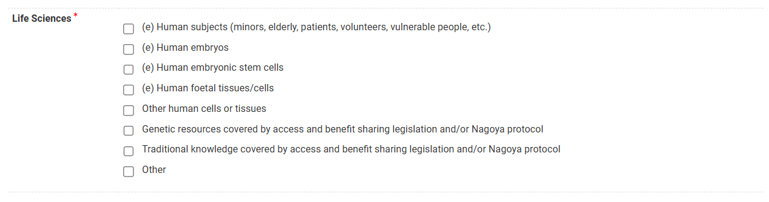

If Animal Welfare ticked:


If Environment, Health & Safety ticked:

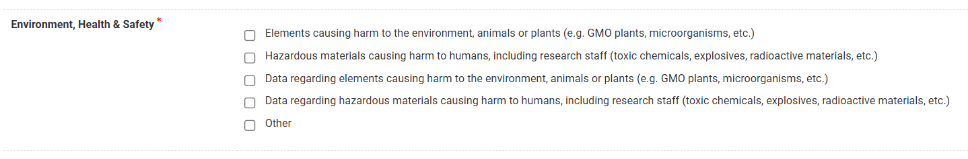

If Interaction with Humans in Social Context ticked:

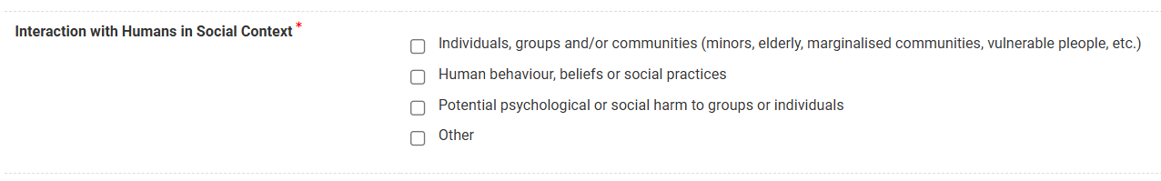
If Data, Privacy and Artificial Intelligence ticked:

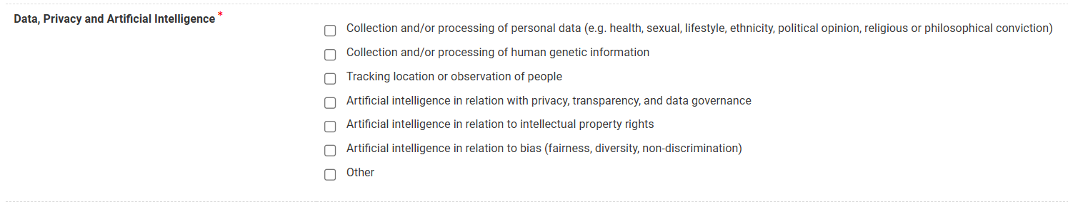
If Colonial, Post-Colonial and Identity ticked:

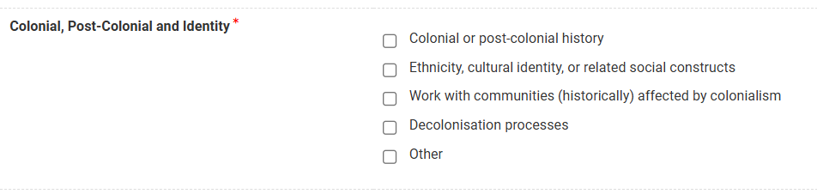
If International Partnerships, Dual-Use and Security ticked:

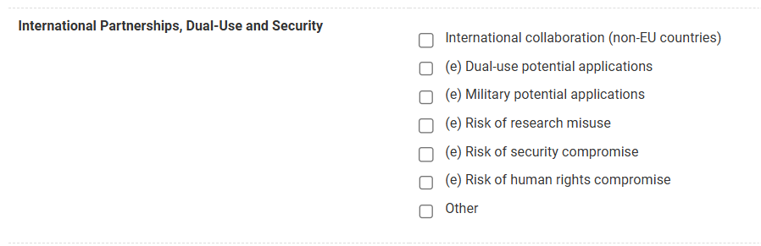
If Other Ethical issues ticked:

16.2 Comments on Ethical and Knowledge Security Issues *
Information:
This question is applicable for all project types.
In this question you will be asked to comment on the different ethical issues marked above and present in your project proposal.
Instructions:
► Please comment on the ethical and knowledge security issues selected above, or explain the absence thereof.
If Ethical and Knowledge Security issues ticked:
Please comment on the ethical / knowledge security issues marked above:
Explanation issues (max. 2000 characters)
If Ethical and/or Knowledge Security Issues do not apply to the project ticked:
Please explain why there are no ethical / knowledge security issues:

Explanation absence of issues (max. 2000 characters)

16.3 Ethics declarations *
Truthful completion | ☐ I confirm that the Ethics form has been filled in sincerely and truthfully.
Obtention of approval  if marked (e) | ☐ I understand that all the ticked boxes marked with (e) trigger an absolute obligation to obtain the ethics approval from the competent ethics committee at the latest before initiating any of the research activities concerned.
Copy of documents | ☐ I will send a copy of the relevant ethic documents confirming the approval from the ethics committee to BELSPO before the start of the research project.
Project termination | ☐ I understand that BELSPO is entitled to request the advice of a relevant ethics committee at any stage of the project. If it appears that the checklist has been filled out incorrectly, or that conditions change during the course of the project, funding of the project may be terminated prematurely.

