Building an evidence base
and lessons learned for
future preparedness
FINAL SCIENTIFIC REPORT

ACRONYM
Title of the project

AUTHOR 1 – Institution
AUTHOR 2 – Institution
AUTHOR 3 – Institution
…


Building an evidence base
and lessons learned for
future preparedness

ACRONYM

Title of the project

Contract N° TD/XX/ACRONYM

PROMOTORS: PROMOTOR 1 (Institution)
PROMOTOR 2 (Institution) PROMOTOR 3 (Institution)
...
AUTHORS: AUTHOR 1 (Institution)
AUTHOR 2 (Institution) AUTHOR 3 (Institution)
...

[Institutions Logo]

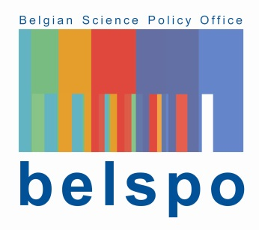
Published in 20xx by the Belgian Science Policy Office
WTCIII
Simon Bolivarlaan 30 bus 7
Boulevard Simon Bolivar 30 bte 7
B-1000 Brussels
Belgium
Tel: +32 (0)2 238 34 11
http://www.belspo.be
https://www.belspo.be/belspo/Post-Covid/index_en.stm

Contact person: Secretariaat POST-COVID
Tel: +32 (0)2 238 34 11 post-covid@belspo.be

Neither the Belgian Science Policy Office nor any person acting on behalf of the Belgian Science Policy Office is responsible for the use which might be made of the following information. The authors are responsible for the content.
No part of this publication may be reproduced, stored in a retrieval system, or transmitted in any form or by any means, electronic, mechanical, photocopying, recording, or otherwise, without indicating the reference:
Authors. Title. Final Report. Brussels: Belgian Science Policy Office 20XX – xx p. (POST-COVID - (Building an evidence base and lessons learned for future preparedness))

table of contents

ABSTRACT 5
1. INTRODUCTION 5
2. MOTIVATION AND OBJECTIVES OF THE OBJECTIVES 5
3. METHODOLOGY 5
4. SCIENTIFIC RESULTS AND RECOMMENDATIONS 5
5. DISSEMINATION AND VALORISATION 5
6. PUBLICATIONS 5
7. ACKNOWLEDGEMENTS 5
ANNEXES 5

ABSTRACT

Context

Objectives

Conclusions

Keywords

1. INTRODUCTION

2. MOTIVATION AND OBJECTIVES OF THE PROJECT

3. METHODOLOGY

4. SCIENTIFIC RESULTS AND RECOMMENDATIONS

5. DISSEMINATION AND VALORISATION

6. PUBLICATIONS

7. ACKNOWLEDGEMENTS

ANNEXES

