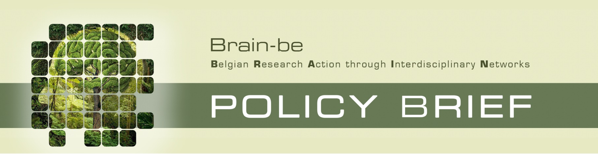

[Title]

[Executive Summary]

Context and question(s) of research
BRAIN-be
The research is funded under the BRAIN-be program of the Federal Science Policy (BELSPO).
BRAIN-BE is a multiannual research framework program launched by BELSPO in 2012 which strengthens the scientific base for policy making and reinforces the strategy and potential of the Federal Scientific Institutions (FSI).
BRAIN-be supports single partner and network projects with a duration of 2 or 4 years. Project selection is based on scientific excellence and the fulfillment of national and international research priorities as well as Federal policy needs.
BRAIN-be covers a wide spectrum of thematics going from sciences systems over cultural heritage, through a number of societal challenges.

[Text]

Main findings
[Text]

[Main findings continued]

Conclusion and recommendations
[Text]

Coordination
Contact
Name, First name:
Institution/Departement:
e-mail:

