BRAIN-be 2.0
BELGIAN RESEARCH ACTION THROUGH INTERDISCIPLINARY NETWORKS - Phase 2

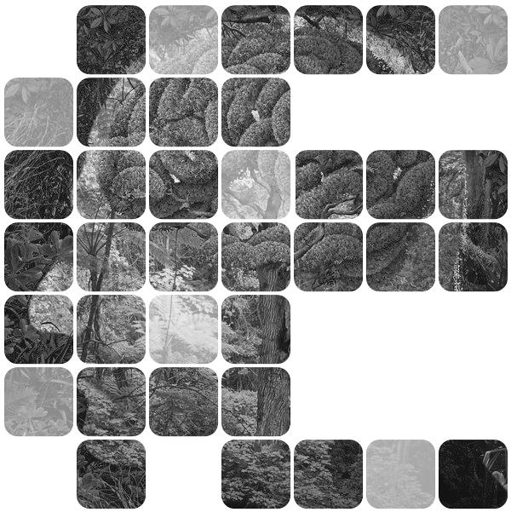
Annual Network Report
To be filled in for the whole network in French, Dutch or English and sent by the coordinator to:
BRAIN-be@belspo.be

Contrat nr: B2 / ... / .. / ...

[Project Acronym]

Reporting period: DD/MM/YY - DD/MM/YY

The Annual Network Report (maximum 15 to 20 pages) is drawn up annually by the coordinator for the entire network and sent by the coordinator to the address BRAIN-be@belspo.be on the dates set in article 4 of annex I to the contract. It presents the state of progress and achievements of the research as well as the forecasts for the following year. This information refers explicitly to the tasks and the project schedule defined in articles 2 and 3 of annex I. It also informs of any modification of the data included in the previous reports – except for the possible changes regarding personnel* - and gives the list of publications and missions carried out during the past year.
This template can be completed in French, Dutch or English.
*Modifications compared to previous reports regarding personnel in charge and at the disposal of the project should be completed by the concerned individual partner in the separate form “Annual Report Personnel” to be downloaded from the website. To be completed conform the instructions given in the Initial Report.

Network

coordinator (partner 1)

- Name and Institution: …

other partners

- Name and Institution: …

- Name and Institution: …

- Name and Institution: …

- ………..

authors of this report

- Name and Institution: …

- Name and Institution: …

- Name and Institution: …

- …………

project website, social networks …

…

table of contents

Network 2
coordinator (partner 1) 2
other partners 2
authors of this report 2
project website, social networks … 2
1. EXECUTIVE SUMMARY of this report 4
2. ACHIEVED WORK 4
3. INTERMEDIARY RESULTS 4
4. PRELIMINARY CONCLUSIONS AND RECOMMANDATIONS 4
5. FUTURE PROSPECTS AND PLANNING 4
6. FOLLOW-UP COMMITTEE 4
7. VALORISATION ACTIVITIES 5
7.1. PUBLICATIONS 5
7.2. PARTICIPATION/ORGANISATION OF SEMINARS (NATIONAL/INTERNATIONAL) 5
7.3. SUPPORT TO DECISION MAKING (IF APPLICABLE) 5
7.4. OTHER 5
8. ENCOUNTERED PROBLEMS AND SOLUTIONS 5
9. POSSIBLE MODIFICATIONS COMPARED TO THE PREVIOUS REPORT 6
COMPOSITION OF THE FOLLOW-UP COMMITTEE 6
10. REMARKS and SUGGESTIONS 6

EXECUTIVE SUMMARY of this report

ACHIEVED WORK
Detailed description of the achieved work and tasks since the previous report

INTERMEDIARY RESULTS
Detailed description of the deliverables completed since the previous report

PRELIMINARY CONCLUSIONS AND RECOMMANDATIONS

FUTURE PROSPECTS AND PLANNING
Overview of the foreseen activities and planning for the next reporting period, taking into account the current state of the work and the intermediary results

FOLLOW-UP COMMITTEE
Date(s) of the meeting(s) and overview of the concrete contributions of the follow-up committee

VALORISATION ACTIVITIES

PUBLICATIONS

PARTICIPATION/ORGANISATION OF SEMINARS (NATIONAL/INTERNATIONAL)
Oral presentations, posters… and/or organisation of workshops, conferences, etc.

SUPPORT TO DECISION MAKING (IF APPLICABLE)

OTHER

ENCOUNTERED PROBLEMS AND SOLUTIONS
Encountered problems/obstacles, implemented and/or considered solutions, if any.

POSSIBLE MODIFICATIONS COMPARED TO THE PREVIOUS REPORT

COMPOSITION OF THE FOLLOW-UP COMMITTEE

REMARKS and SUGGESTIONS
Concerning for example: the coordination, the use or valorisation of the results, personnel change …

