**BELSPO final Post-Doc Research Report for Dr. Rajesh Tewari**

**BELSPO Post-Doc. Candidate:** Dr. Rajesh Tewari

**Start date:** December 1, 2012

**End date:** November 30, 2013

**Title:**. **Unravelling mode of action of ionising radiation induced adverse effects in *Arabidopsis thaliana* through transcriptomic profiling.**

**Host Institute:** Belgian Nuclear Research Centre

**SCK•CEN mentor:** Dr. Nele Horemans, Dr. Hildegarde Vandenhove

# Purpose of proposed Research Plan

Each step in the nuclear fuel cycle, from the mining and milling of uranium ores over the power regeneration and finally the radioactive waste disposal, potentially leads to increased radiation risk to the environment (Vandenhove, 2002). In recent years, considerable efforts have been made to develop a framework, criteria and a methodological approach (see e.g., Copplestone et al., 2004) to judge the risks associated with exposure of non-human biota to radioactivity. As a result, a general screening value of 10µGy/h protective for all ecosystems was derived (Andersson et al., 2009). At this moment the major challenge remains to enhance the robustness and scientific credibility of this screening value and of the environmental protection criteria (Salbu & Skipperud, 2007). This includes an improved understanding of mechanisms and processes affecting radionuclide behaviour and their effects to non-human biota on different levels of biological organisation (Andersson et al., 2009).

All ionizing radiation has the potential to cause ionization with subsequent cellular damage. The physical absorption of ionizing radiation may directly result DNA damage or in free radical formation. Ionising radiation and radionuclides, like other abiotic stresses, often lead to the increase in the formation of highly reactive oxygen species (ROS) which may cause oxidative stress, a disturbance of the cellular redox status. These cytotoxic species of oxygen can seriously disrupt normal metabolism through oxidative damage to cellular components but are also known to act as signalling molecules. Although a number of recent studies describe the induction of oxidative stress in plants after exposure to radiation or uranium none of these studies as yet reported about ROS and nitric oxide (NO) generation in uranium exposed plants**.**

**Objectives**

The objective of the present study was to conduct hypothesis-driven experiments and focus on biological effects of uranium and gamma exposure on ROS and NO generation in *Arabidopsis thaliana*. Within the overarching goal following sub-goals were distinguished:

1. Study gamma radiation induced growth and oxidative stress responses in a dose-dependent manner to and possibly identify a γ-radiation specific transcriptomics fingerprint in *Arabidopsis thaliana.*
2. Optimization of protocols for ROS and NO detection and determine whether uranium exposure induced NO and H2O2 generation in *Arbidopsis thaliana* plants.
3. Unravelling role of NO in uranium-induced oxidative stress in *Arabidopsis thaliana*.
4. Linking the role of NO in U-induced chlorophyll biosynthesis in *Arabidopsis thaliana.*

**Achievements**

**Experimental approach and Results**

**OBJECTIVE 1: Gamma radiation induced growth and oxidative stress responses in *Arbidopsis thaliana* plants**

In all experiments conducted in this project *Arabidopsis thaliana* plants were grown in modified Hoagland medium (final concentration of salts: 1.0 mM KNO3, 0.3 mM Ca(NO3)2, 0.2 mM MgSO4, 0.1 mM NH4H2PO4, 1.62 µM FeSO4, 0.78 µM Na2EDTA.2H2O, 4.6 µM H3BO3, 0.9 µM MnCl2, 32 nM CuSO4, 56.6 nM H2MoO4, 76.5 nM ZnSO4) under hydroponic culture condition as previously described (Vanhoudt et al., 2008). Prior to this project an experiment was performed in which 18-day old *Arabidopsis* seedlings were exposed to different gamma dose rates for one week. Although this induced differences for example in photosynthesis efficiency, these plants did not show any obvious growth effects (Vanhoudt et al., in press, *DOI: 10.1016/j.jenvrad.2013.11.011*). Based on the results of Vanhoudt et al. it was opted here to increase the total dose absorbed by the plants without increasing the dose rates but by exposing one-week old seedlings during 14 days. As such plants were exposed to 21.5; 36.3; 79.2 or 321 mGy/h resulting in a total dose of 7.1; 12.0; 26.2 or 106 Gy, respectively. At harvest biomass of plants was measured for roots and shoots separately and root and shoot tissue was snap-frozen for further analysis. The concentration and redox status of the two major antioxidants ascorbate (ASC) and glutathione (GSH) was measured. To unravel the oxidative stress response and find a possible gamma-specific transcriptomic response the transcription of different oxidative stress related genes: Respiratory burst oxidase homologue (RBOH-B,C,E,G,H and I), lipoxigenase (LOX1-6), catalase (CAT1and 2), glutathione reductase (GR1), Cu-Zn superoxide dismutase (CSD1), Fe superoxide dismutase (FSD1 and 2), and DNA damage and repair genes, namely Kip related protein (KRP2), meiotic nuclear division1 homolog (MND1), poly(ADP-ribose) polymerase (PARP1 and 2). Additionally the enzymatic activity of different antioxidative enzyems superoxide dismutase (SOD), Ascorbate peroxidase (APX), glutathione reductase (GR), guaiacol peroxidase (GPX), syringaldizine peroxidase (SPX) and catalase (CAT) was determined in root or shoot extracts. Metabolites glutathione (GSSG – oxidised; GSH – reduced) and ascorbate (ASC) and dehydroascorbate (DHA) were also monitored.

**Fourteen day exposure to gamma radiation results in a dose-dependent antioxidative response.**

The biomass of plants exposed to different gamma dose rates for 14 days was in general significantly smaller than the control (Fig 1). However, as the control was kept in a room adjacent to the exposure room it cannot be completed excluded that this difference is due to small differences in growth circumstances rather than exposure to gamma radiation. Comparing the different dose rates it seems that gamma radiation had a small growth promoting effect until a dose rate of 79.2 mGy h-1, whereafter growth again slowed down in both roots and shoots.

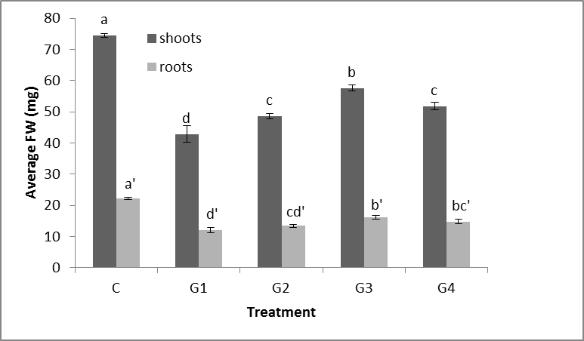

**Figure 1: Fresh weight [mg] of roots and leaves of *Arabidopsis* seedlings exposed to 21.45 (G1) 36.25(G2), 79.15 (G3) 320.5 (G4) mGy h-1 of gamma radiation for 14 days. Data represent the mean ± SE of at least 100 biological replicates. Different letters indicate significant differences between the treatments (p<0.05).**

The activity of different antioxidative enzymes was analysed in the plants exposed to 14days to different levels of gamma radiation (Fig. 2A and 2B). Most enzymes showed a similar activity pattern in roots and shoots. In general enzyme activity did not show a significant difference compared to control (CAT, SOD) or was decreasing (SPX, APX) with increasing dose-rates. Only GPX activity was strongly induced at the lowest dose rate in leaves compared to control. Also in roots GPX was induced compared to control. However, GR showed a striking different response in roots compared to shoots. Whereas in shoots a dose dependent decrease in GR activity is observed, the activity of this enzyme is clearly induced in the roots. This pattern coincided with the redox state of GSH that was increasing *i.e.*  more reduced in the roots whereas it was not significantly different in the shoots (data not shown). In addition the overall GSH+GSSG levels in shoots were decreasing with increasing dose rate in contrast to that in the roots. Therefore it is conceivable that the need for GR activity in the shoots is less at higher dose rates and still GSH redox status is maintained.

The levels of ASC in the plant roots increase with increasing dose rate indicating plants are actively responding to the gamma-induced oxidative stress. This is, however, accompanied with a transient increase of DHA but roots exposed for 14 days to the highest gamma dose rates are still clearly able to keep a high redox status of the major antioxidants. Results on enzyme activity are mostly supported by similar increases or decreases in transcript levels of the different antioxidative enzymes (data not shown). Only the expression of GR was high in both roots and shoots despite the dose dependent decrease in GR activity levels in the shoots. Similar to the results obtained after 7 days (Vanhoudt et al. 2014) we observed an increasing trend in APX activity with increasing dose rate in both roots and shoots (data not shown).

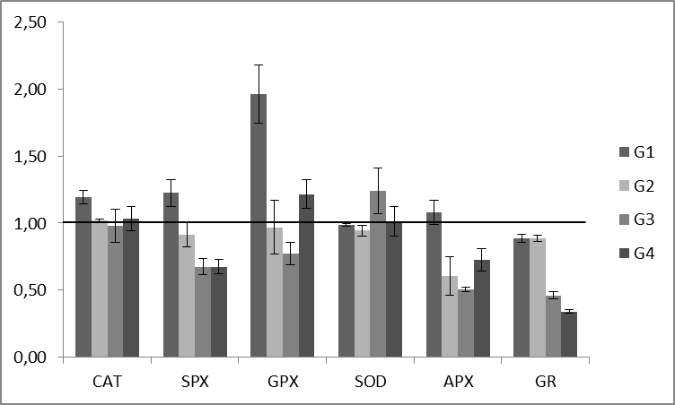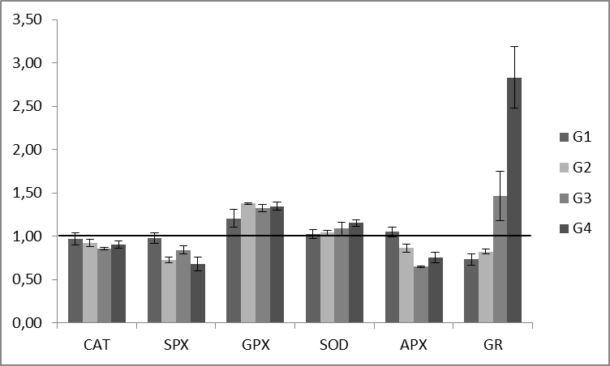

B

A

**Figure 2: Capacities of reactive oxygen species (ROS)-scavenging enzymes in Arabidopsis leaves (A) and roots (B) exposed to 21.45 (G1) 36.25(G2), 79.15 (G3) 320.5 (G4) mGy h-1 of gamma radiation for 14 days and expressed relative to the control (line). Data represent the mean ± SE of 6 biological replicates.**

**Correlation of gene-expression with gamma dose in roots**

In search of a potential transcriptomic fingerprint for gamma radiation-induced oxidative stress or DNA damage in plants we further analysed the transcription levels of genes involved in the active induction of ROS in plants, and in DNA damage and repair (see Fig. 3 for expression of a limited number of antioxidative genes, results of other gene expression analysis as indicated higher). Unfortunately, expression in leaves of control plants of all tested genes was very high compared to radiation-exposed ones independent of the dose rates applied. Therefore it is at this point hard to compare expression levels in leaves. In roots, however, clear radiation-dependent patterns could be observed (Fig. 3). As such expression of several respiratory burst homologue (RBOH) genes increased in a dose-dependent manner in the roots. In addition also lipoxygenases were induced (LOX4, Fig 3). The induction of RBOHs and LOX-genes indicate the induction of free radicals either through the formation of superoxide or the peroxidation of membrane lipids with the concomitant production of peroxy radicals as well as singlet oxygen. This formation of ROS is in addition to the hydrolysis of water known to be induced by gamma radiation. Hence exposure of plant roots to gamma radiation induces a substantive and long lasting oxidative burst in plants or at least in the roots. In addition RBOHs as well as LOX have been implicated in signal transduction pathways and the regulation of the oxidative stress responses in plants. As such their induction also indicates that plants are actively defending themselves against the radiation induced stress.

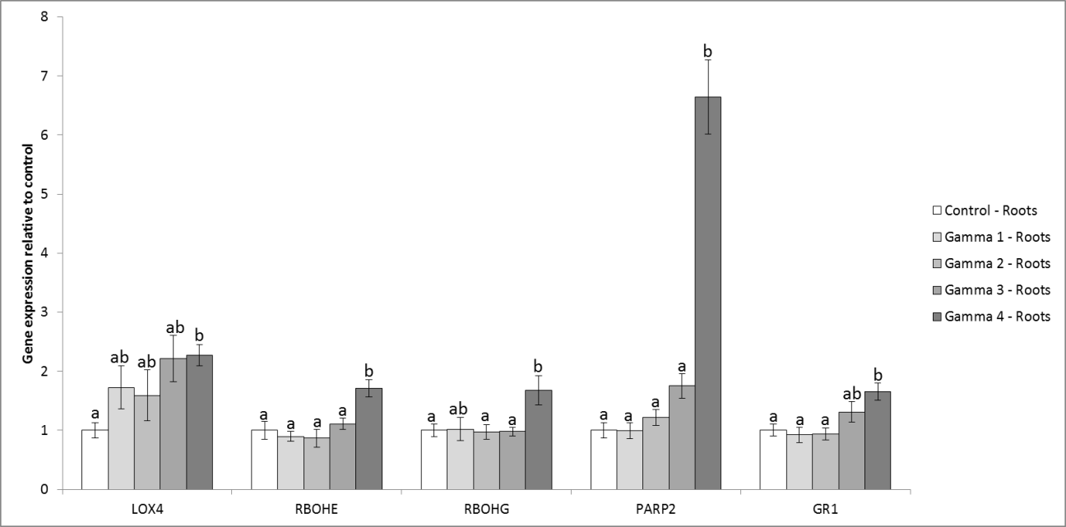

**Figure 3: Relative gene expression levels of a limited number of genes involved in oxidative stress and DNA damage and repair in of Arabidopsis roots exposed to 21.45 (G1) 36.25(G2), 79.15 (G3) 320.5 (G4) mGy h-1 of gamma radiation for 14 days and expressed relative to the control (control is set at 1). Data represent the mean ± SE of 4 biological replicates.**

Based on previous results, only a limited number of genes involved in DNA damage and repair were tested for gene expression. The most prominent change after exposure for 14 days to gamma radiation was found in Poly- (ADP-ribose) polymerase 2 (PARP2) expression (Fig. 3) PARP2 is a protein involved in DNA repair after single strand breaks and in protein deacetylation. In addition it has been attributed roles in the maintenance of genomic integrity, control of cell cycle and in oxidative signal transduction and is often induced in oxidative stress conditions.

In general we can conclude from these results that after 14 days exposure, despite the observed decrease in growth, plants have re-established major oxidative stress defence mechanisms also at higher dose rates.

**OBJECTIVE 2: Optimization of protocols for H2O2 and NO detection in uranium exposed *Arbidopsis thaliana* plants**

Plants were grown hydroponically as described above for 18-days and were subsequently exposed to 25 µM U for three days. At harvest plants were frozen in liquid nitrogen for the various analysis including nitrite, hydrogen peroxide measurement by spectrophotometer. NO and H2O2 were localized in the freshly harvested roots by NO selective dye, DAF-2DA and H2O2-selective dye, H2DCF-DA.

**Nitric oxide localization: protocol optimisation**

Various loading buffers such as phosphate buffer saline (PBS), Tris-HCl and MES were tried for better localization with minimum auto-oxidation of dye. Time duration and concentration of loading dye were also optimized. PBS and Tris-HCl buffer induced autooxidation of diaminoﬂuorescein-2 diacetate (DAF-2DA) and also induced autofluorescence in the roots. On the basis various experimental trials, following protocol for NO detection was found to be optimal for the *Arabidopsis* roots*: Arabidopsis* seedlings were placed in a loading buffer [5 mM 4-morpholineethanesulfonic acid (MES)-KOH, pH 5.7, 0.25 mM KCl, 1 mM CaCl2] with or without 200 µM methylene blue (MB, a NO scavenger) for 30 min prior to the addition of 5 µM DAF-2DA for 1 h in dark, and then rinsed in loading buffer for 3 times for 5 min each. The ﬂuorescence of distal regions of roots was monitored with a Nikon Eclipse Ti ﬂuorescence microscope using a FITC filter. Similarly treated unstained roots were used as controls to subtract autoﬂuorescence of experimental samples.

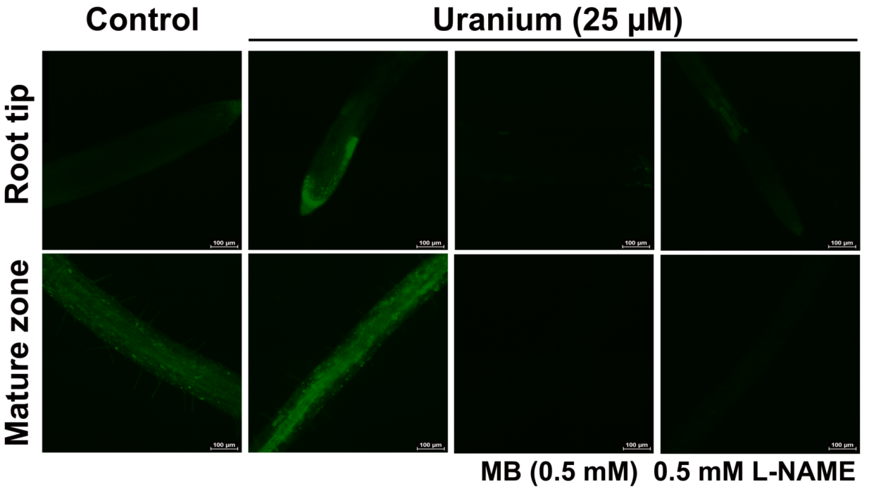

**Figure 4 NO localization in *Arabidopsis thaliana* roots exposed to 0 µM (control) and 25 µM uranium. MB (0.5 mM was used as NO scavenger) and 0.5 mM L-NAME (NO synthase inhibitor) abolished NO fluorescence.**

As indicated in Figure 4 a distinct U-induced NO production could be observed that disappeared in the presence of MB or L-NAME (NO-synthase inhibitor).

**Hydrogen peroxide localization and protocol optimisation**

For H2O2 localization using 2,7-dichlorodihydroﬂuorescein diacetate (H2DCF-DA) various concentration of this dye and various buffers were tried to improve sensitivity of H2O2 detection in *Arabidopsis* roots. Following protocol was found to be optimal. Images obtained from this protocol are depicted in Figure 5: *Arabidopsis* roots were placed in loading buffer (5 mM 4-morpholineethanesulfonic acid (MES)-KOH, pH 5.7, 0.25 mM KCl, 1 mM CaCl2 0.5M sorbitol) containing 10 µM 2,7-dichlorodihydroﬂuorescein diacetate (H2DCF-DA) for 30 min. Roots were washed for 15 min in 5 mM MES buffer (pH 5.7) with changes. Roots were mounted on the microscope slides using same buffer and DCF-fluorescence were monitored with a Nikon Eclipse Ti ﬂuorescence microscope using a FITC filter.

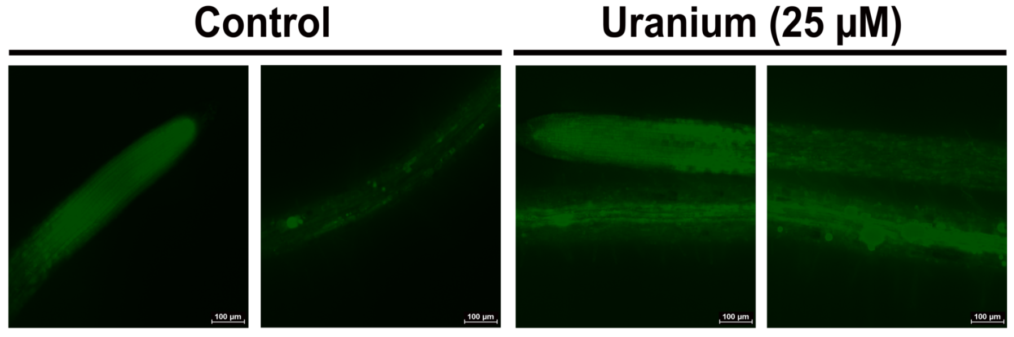

**Figure 5: H2O2 localization in Arabidopsis roots exposed to 0 µM (control) and 25 µM Uranium.**

**Nitrite measurement**

Nitrite content was determined as described previously (Tewari et al., 2013). Root tissue (100 mg) was frozen in liquid N2 and powdered using shredder and tungtun carbide beads. The frozen root powder was extracted in 2 ml 50 mM acetate buffer pH 3.6, containing 4.0 % (w/v) zinc diacetate. Equal amount of plant extract and Greiss reagent were incubated at 37°C for 90 min. Similarly, nitrate plus nitrite was measured in the same extract by including VCl3 for reduction of nitrate to nitrite. Absorbance was determined at 540 nm. Nitrite content was calculated by comparison to a standard curve of NaNO2.

**Hydrogen peroxide measurement**

H2O2 was determined in root and leaf tissue as H2O2-titanium complex with modification (Brennan & Frenkel, 1977). *Arabidopsis* root and leaf tissues (100 mg FW) were extracted in 0.5 ml ice-cold acetone and centrifuged at 10000×g for 5 min at 4°C. Supernatant (0.2 ml) and water (0.1 ml) were mixed and reacted with 0.06 ml of 10 % (v/v) titanium tetrachloride (diluted in conc. HCl). H2O2-titanium complex was precipitated with 0.06 ml ammonia solution. The precipitate was washed repeatedly with cold acetone to remove chloroplastic pigments and excess ammonia and dissolved in a 0.3 ml 2N H2SO4. Absorbance of solution was monitored at 415 nm. Amount of H2O2 was calculated using a calibration curve generated with known concentration of H2O2.

DAF-2T and DCF-fluorescence observed under a fluorescence microscope indicated induction of NO and H2O2 in 25 µM U exposed roots. Calorimetric determination of nitrite and H2O2 with Greiss and titanium reagent respectively further confirm that uranium exposure indeed induced NO and H2O2 production in both *Arabidopsis* roots and shoots (Fig. 6).



**Figure 6: NO (nitrite) and H2O2 concentration in *Arabidopsis* roots and shoots exposed to 25 µM U. Bars with different letters are statistically significant (p ≤0.05).**

**Significance of experiments**

Protocols for H2O2 and NO visualization were improved. DAF-2DA is a highly expensive chemical by reducing the concentration of loading dye to 1/2 to that of the reported concentration (Corpas et al., 2004) in present protocol the cost of analysis was significantly reduced. .The concentration of the H2O2-probe H2DCF-DA could also be decreased to 10 times of reported concentration of H2DCF-DA. Background fluorescence and autofluorescence of roots were minimized and the sensitivity of NO and H2O2 localization is therefore improved significantly.

**OBJECTIVE 3: Unravelling the role of NO in uranium-induced oxidative stress in *Arabidopsis thaliana*.**

**Methods**

To elucidate the role of NO in U-induced oxidative stress, *Arabidopsis* plants were grown for 3-weeks and treated for 3-days under hydroponic culture conditions. Initial experiments was conducted with wild-type, Col 0, plants either in mock-treated (control) conditions or treated with 200 µM sodium nitroprusside (SNP, NO producer), 200 µM methylene blue (MB, NO scavenger), 200 µM Nω-Nitro-L-arginine methyl ester (L-NAME, NOS inhibitor) with or without 25 µM U added. In second series of experiments *Arabidopsis* plants, wild-type Col 0 and *Atnia1,2noa1-2* and *Atnoa1* mutants were grown for 4-week and mock-treated (control) conditions or treated with 200 µM SNP, SNP+U (25µM), and U (25µM). On day four plants were sampled and frozen in liquid nitrogen for the various analyses including nitrite, hydrogen peroxide, antioxidant enzymes and antioxidant redox couples (ascorbic acid, dehydroascorbic acid, glutathione sulphydryl and glutathione disulphide) as previously described (Saenen et al., 2013). NO and H2O2 were localized in the roots by DAF-2DA and H2DCF-DA, respectively. Moreover, expressions of genes involved in oxidative stress and antioxidant defence were also analysed.

**Results**

Plant growth was inhibited by 25 µM uranium. Growth (leaf area and fresh weight) was additionally retarded by an exogenous application of NO scavenger, MB. An improvement in plants growth, which is retarded by uranium exposure, was observed on an exogenous application of NO producer, SNP, along with U. NOS inhibitor did not induce any significant effect on leaf area (Fig. 7).

A

B



Figure 7: Effect of NO producer (200 µM SNP), NO scavenger (200 µM MB) and NOS inhibitor (200 µM L-NAME) on leaf area (A) and fresh weight (B) of *Arabidopsis* plants exposed to 25µM U. Data bars are mean ± SE (n=6). Bars with different letters are statistically significant (p≤0.05) for an individual parameter in an individual plant organ.

Shoot growth was found to be related to nitrite accumulation in MB treated plants. Moreover, these plants have relatively less nitrate concentration (Fig. 7 A, B). MB treated plants also accumulated H2O2 and lipid peroxide both in shoots and roots as well (Figs. 8 C, D). An exogenous application of NO producer, SNP, protected U exposed shoots from oxidative damage despite an excess accumulation of H2O2 in shoots. These observations suggest that an exogenous application of NO producer, SNP, plays a protective role in U-induced oxidative damage in *Arabidopsis thaliana*.



Figure 8: Effect of NO producer (200 µM SNP), and NO scavenger (200 µM MB) on nitrate (A) and nitrite (B) concentrations and lipid peroxidation (C) and H2O2 (D) levels in *Arabidopsis* plants exposed to 25 µM U. Data bars are mean ± SE (n=6). Bars with different letters are statistically significant (p≤0.05) for an individual parameter in an individual plant organ.

**OBJECTIVE 4: Linking the role of NO in uranium-induced chlorophyll biosynthesis in *Arabidopsis thaliana.***

To further unravel the possible role of NO in U-induced chlorophyll biosynthesis *Arabidopsis* wild-type Col 0 and mutant deficient in NO generation (*Atnoa1*) were grown for 4-week and exposed for 3-days under hydroponic culture conditions. These plants, wild-type Col 0 and *Atnoa1* mutant were either mock-treated (control) or treated with 200 µM sodium nitroprusside (SNP), SNP+U (25µM), and U (25µM). After 3 days exposure, plants were sampled and frozen in liquid nitrogen for the various analyses including fresh weight, dry weight, U-uptake, NO levels, chloroplastic pigments – chl *a*, chl *b*, carotenoids concentration, glutamate-1-semialdehyde (GSA), 5-aminolevulenic acid, ALA-dehydratase and PBG deaminase activities and various transcripts (*GSA 1, POR B, POR C, FeCh II, HO 3, CAO,* and *CHL D and CHL I-1*) involved in chlorophyll biosynthesis were analysed.

**Results**

Mutant plants were significantly smaller than wild-type *Arabidopsis* plants, however, fresh weight and dry weight of shoot and roots plants was not affected significantly after 3 days of U exposure or by treatment of SNP (Fig. 9). *Atnoa1* plants were growing slower and were pale more in colour compared to wild type plants. The mutants started synthesising chlorophyll and turned green after 3 days of U exposure (Fig. 10). These observations suggest that U induced chlorophyll biosynthesis in *Atnoa1* plants deficient in NO synthesis. *Atnoa1* plants do produce NO in roots on U exposure as indicated by an increase in DAF-2T fluorescence. An increase in nitrite concentration in shoots on U exposure also indicated NO generation therein (data not shown).



Figure 9: Fresh weight and dry weight of 4-week-old *Arabidopsis thaliana* wild-type Col 0 and *Atnoa1* plants either untreated (control) or treated with 200 µM SNP, SNP+ 25 µM U, or 25 µM U for three days. Data represented mean±SE (n=6).

Both wild-type, Col 0 and *Atnoa* 1 mutant enhanced chlorophyll and carotenoids concentrations on exposure to 25 µM U and combined treatment of U with 200 µM SNP. Effect of U on chlorophyll a was found to be highly prominent, which was also reflected by an increase in chl a/b ratio. This observation suggests that U has a significant effect on chlorophyll a biosynthesis. Chlorophyll b and carotenoids concentrations were also enhanced in wild-type Col 0 and *Atnoa1* mutants on U exposure (Fig. 10).



Figure 10: Chloroplastic pigments (chl a, chl b and carotenoids) concentrations and chl a/ b and chl/car ratio in *Arabidopsis thaliana* wild-type Col 0 and *Atnoa1* 4-week-old plants either untreated (control) or treated with 200 µM SNP, SNP+ 25 µM U, or 25 µM U for three days. Data are mean±SE of replicates (n=6).

Moreover, an increase in glutamate-1-semialdehyde (GSA), and 5-aminolevulinic acid (ALA) concentrations and ALA dehydratase, porphobilinogen deaminase activities and upregulated expression various transcripts involved in chlorophyll biosynthesis (*GSA 1, POR A, POR B, POR C, FeCh II, HO 3, CAO,* and *CHL D and CHL I-1*) especially in NO-deficient *Atnoa1* mutants treated with SNP or U suggest that NO is indeed involved U-induced chlorophyll biosynthesis and U is a beneficial element for chlorophyll biosynthesis (data not shown).

**Significance of work**

NO and H2O2 are not only free radicals but they are also signalling molecules. No report is as yet available on NO and H2O2 generation in uranium exposed *Arabidopsis thaliana* or any other plants. Therefore, present work added a new dimension in current knowledge about uranium toxicity. Moreover, present work firmly established for the first time the involvement of uranium-induced NO in chlorophyll biosynthesis in *Arabidopsis thaliana*. Future experiment might further elucidate the role of U and NO in chlorophyll biosynthesis and in its role in the response of plants to U.

**Problems/issues, if any:** None

**Scientific output:**

**Tewari RK**, Horemans N, Nauts R, Wannijn J, Plevoets J, Van Hees M, Vandenhove H (2013) Uranium exposure induced reactive oxygen species and nitric oxide generation in *Arabidopsis thaliana. Presented* In: *11th International Conference on Reactive Oxygen and Nitrogen Species in Plants*. July 17-19th 2013, at the Warsaw University of Life Sciences-SGGW (WULS-SGGW), Poland

**Papers under preparation**

1. Horemans N, Tewari R, Vanhoudt N, Nauts R, Wannijn J, Van Hees M, Saenen E, Vandenhove H (XXXX) Oxidative stress response in *Arabidopsis thaliana* chronically exposed to gamma radiation, J. Environ Radioactiv
2. Tewari RK, Horemans N, Nauts R, Wanijn J, Van Hees M, Vandenhove H (XXXX) The alleged nitric oxide suppressed *Arabidopsis* mutants- *Atnoa1* and *Atnia1nia2noa1-2* produce nitric oxide in MS growth medium and on uranium exposure. New Phytol.
3. Tewari RK, Horemans N, Nauts R, Van Hees M, Wanijn J, Vandenhove H (XXXX) Uranium exposure induces nitric oxide and hydrogen peroxide generation in *Arabidopsis thaliana.* J. Plant Physiol.
4. Tewari RK, Horemans N, Nauts R, Saenen E, Wanijn J, Van Hees M, Vandenhove H (XXXX) Involvement of nitric oxide in uranium-induced chlorophyll biosynthesis in *Arabidopsis thaliana.* J. Plant Physiol.
5. Tewari RK, Horemans N, Nauts R, Wanijn J, Van Hees M, Van Hoeck A, Vandenhove H (XXXX) Role of nitric oxide in uranium-induced oxidative stress and antioxidant defence in *Arabidopsis thaliana.* Environ. Exp. Bot.

**References**

Andersson P, Garnier-Laplace J, Beresford NA*, et al.*, 2009. Protection of the environment from ionising radiation in a regulatory context (protect): proposed numerical benchmark values. *Journal of Environmental Radioactivity* **100**, 1100-8.

Brennan T, Frenkel C, 1977. Involvement of hydrogen peroxide in the regulation of senescence in pear. *Plant Physiology* **59**, 411-6.

Copplestone D, Howard BJ, Brechignac F, 2004. The ecological relevance of current approaches for environmental protection from exposure to ionising radiation. *Journal of Environmental Radioactivity* **74**, 31-41.

Corpas FJ, Barroso JB, Carreras A*, et al.*, 2004. Cellular and Subcellular Localization of Endogenous Nitric Oxide in Young and Senescent Pea Plants. *Plant Physiology* **136**, 2722-33.

Saenen E, Horemans N, Vanhoudt N*, et al.*, 2013. Effects of pH on uranium uptake and oxidative stress responses induced in Arabidopsis thaliana. *Environmental Toxicology and Chemistry* **32**, 2125-33.

Salbu B, Skipperud L, 2007. Challenges in radioecotoxicology. In: Mothersill C, Mosse I, Seymour C, eds. *Multiple Stressors: A Challenge for the Future.* Dordrecht: Springer, 3-12. (Nato Science for Peace and Security Series C - Environmental Security; vol.)

Tewari RK, Prommer J, Watanabe M, 2013. Endogenous nitric oxide generation in protoplast chloroplasts. *Plant Cell Reports* **32**, 31-44.

Vandenhove H, 2002. European sites contaminated by residues from the ore-extracting and -processing industries. *International Congress series* **1225**, 307-15.

Vanhoudt N, Horemans N, Wannijn J, Nauts R, Van Hees M, Vandenhove H (2014) Primary stress responses in *Arabidopsis thaliana* exposed to gamma radiation. *Journal of Environmental Radioactivity* **129,** 1-6

Vanhoudt N, Vandenhove H, Smeets K*, et al.*, 2008. Effects of uranium and phosphate concentrations on oxidative stress related responses induced in *Arabidopsis thaliana*. *Plant Physiology and Biochemistry* **46**, 987-96.