Belgium-Vietnam Research and TechnologyCooperation

CALL FOR RESEARCHPROPOSALS 2018 'CLIMDIS'

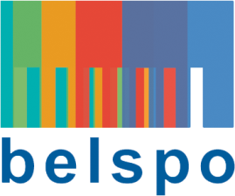
Check list

Eligibility of proposals for Belgian partners

Please check at the submission of your proposal if it fulfils all the eligibility criteria; BELSPO's evaluation process starts with the check of the list. The coordinators from whom the proposal(s) are not eligible are informed by BELSPO.
The eligibility of proposals is evaluated on the basis of the information given by the applicants in the submission dossier.

List of criteria
Each proposal is checked (up)on the following criteria. Only proposals fulfilling ALL the criteria are evaluated.

- The submission dossier is received , in English, at latest on 24th May 2018, at 15h
- The submission dossier is transmitted at Belgian side (BELSPO) and at the Vietnamese side (MOST), signed by both coordinators
- The network consists of at least 1 Belgian participant from a university or a public scientific institution or a non-profit research center
- The dossier addressed to BELSPO includes the 2 requested correctly filled in forms (English form + form regarding the budget in Dutch or French)
- The submission dossier is provided by electronic version (in Word en in Pdf)
- In case that an optional partner participates in the project, the letter mentioning the funding by a funding source different from MOST or BELSPO is to be included in the submission dossier
- The proposal complies with the rules described under the title 'budget' of the submission dossier
- The budget contribution requested to BELSPO does not exceed 125.000 EUR
- De duration of the proposed project is maximum 3 years

A acknowledgement of receipt is send.
The form in Dutch or French concerning the budget is ment only to BELSPO.

