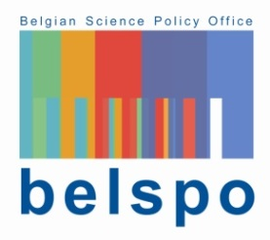

Belgium- China - South-Africa Research Cooperation
Call for Proposals 2020
BELSPO Check list 'ELIGIBILITY of Proposals 'BIOCLIMHEALTH'

The Belgian Science Policy Office (BELSPO) ensures that proposals meet all the eligibility criteria listed below. Proposals that do not meet one or more eligibility criteria will not be evaluated.
The Principal Investigators of ineligible proposals will be informed by BELSPO. The eligibility of each proposal is verified on the basis of information provided by the submitters in the submission file.

List of criteria
Each proposal is checked on the following criteria. Only proposals fulfilling ALL criteria will be evaluated.

- The submission dossier is submitted to BELSPO the latest on 27th November 2020, at 15h[1]
- The submitted dossier fits to the content of the call (in/out of scope)
- The submission dossier is provided in electronic version, in Pdf and in Word format and signed by the 3 coordinators
- The network consists of participants from universities and/or public scientific institutions, and/or non-profit research centres
- The proposal concerns a research project with at least 1 principal investigator from each country
- At least one of the Belgian partners is a promoter supported by BELSPO via one of the mentioned programmes or be affiliated with a federal scientific institution
- In case that an optional partner participates in the project, the letter mentioning its funding by a funding source different from BELSPO, MOST(China) or NRF (South-Africa) is included in the submission dossier
- The proposal complies with the rules written in the rubric 'budget' of the submission dossier
- The budget requested from BELSPO does not exceed 175.000 EUR
- De duration of the proposed project is between 2,5 and 3 years

[1]A proof of reception is sent.

