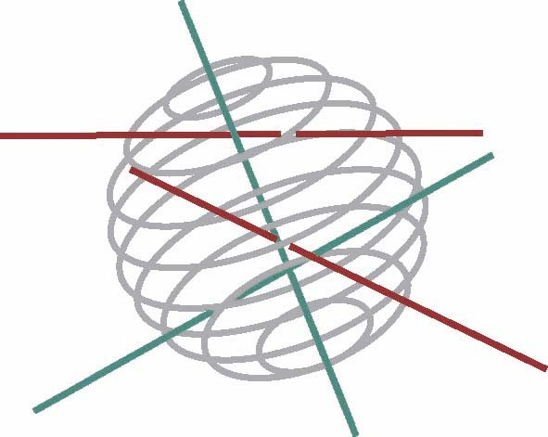

BELGIAN FEDERAL PUBLIC
PLANNING SERVICE
SCIENCE POLICY

Research programme
Science for a Sustainable Development (SSD)

Call for proposals nr 3

Energy

Expression of interest

Closing date: 16 March 2007

To be sent to SSD_call3@belspo.be

Mandatory for the submission of a research proposal

Proposal’s acronym:
Proposal’s title (maximum 12 words) :

Name of the coordinator:
Institution:
Department:
E-mail:

Possible partners:
Name:
Institution:
Department:
E-mail:
Name:
Institution:
Department:
E-mail:
Name:
Institution:
Department:
E-mail:
Name:
Institution:
Department:
E-mail:

Short description of the research proposal (domain, objectives, methodology,…):
(maximum 20 lines)
Keywords (maximum 6):

