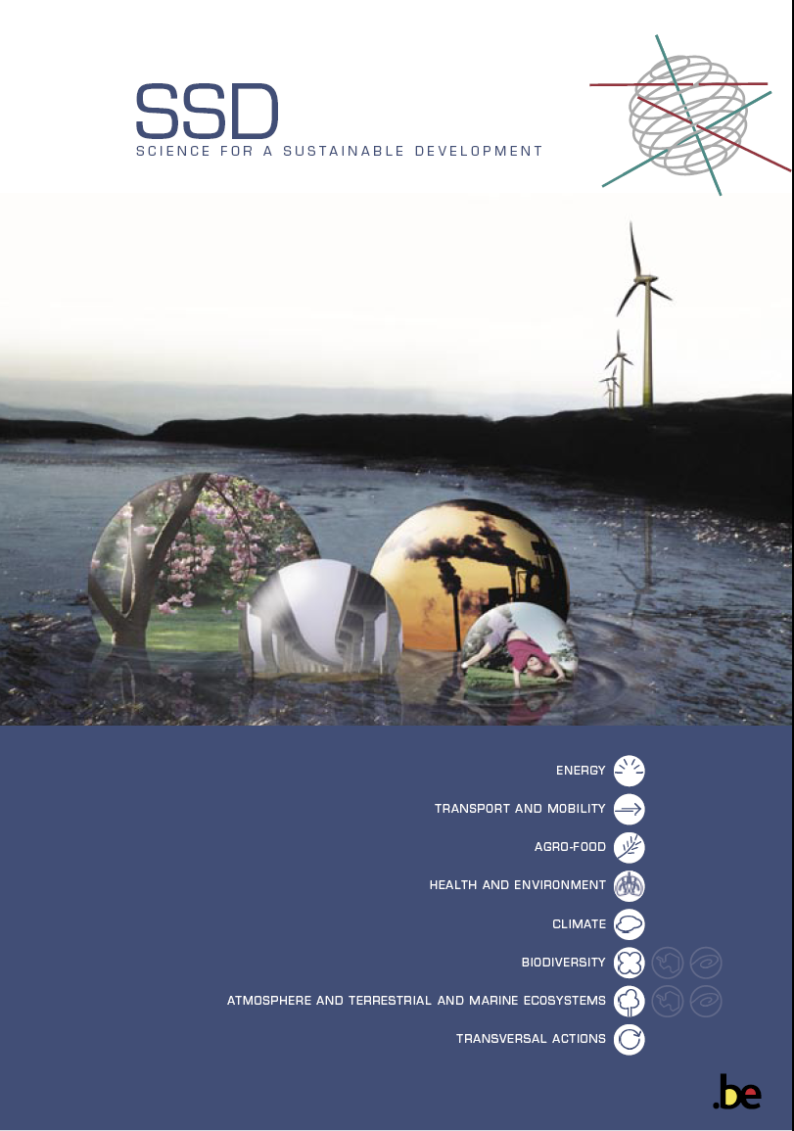

“Title”

«Acronym»
Authors
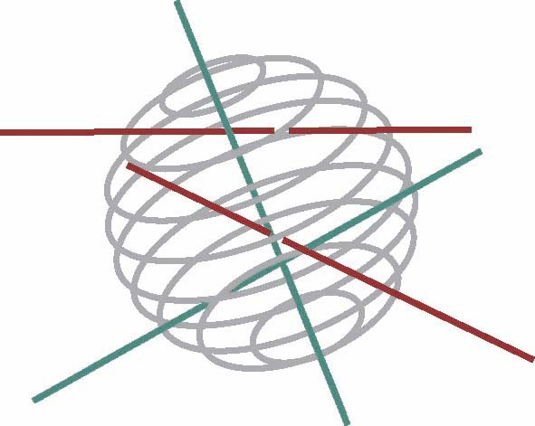
Science for a sustainable development
(SSD)

Thematic (Climate, Biodiversity.....)

FINAL REPORT

TITLE
“acronym”

SD/XX/XX

Promotors
XXX (Institution+ address)
XXX (Institution+ address)
XXX (Institution+ address)
XXX (Institution+ address)

Authors
XXX (Institution)
XXX (Institution)
XXX (Institution)
XXX (Institution)

Institutions’ logo

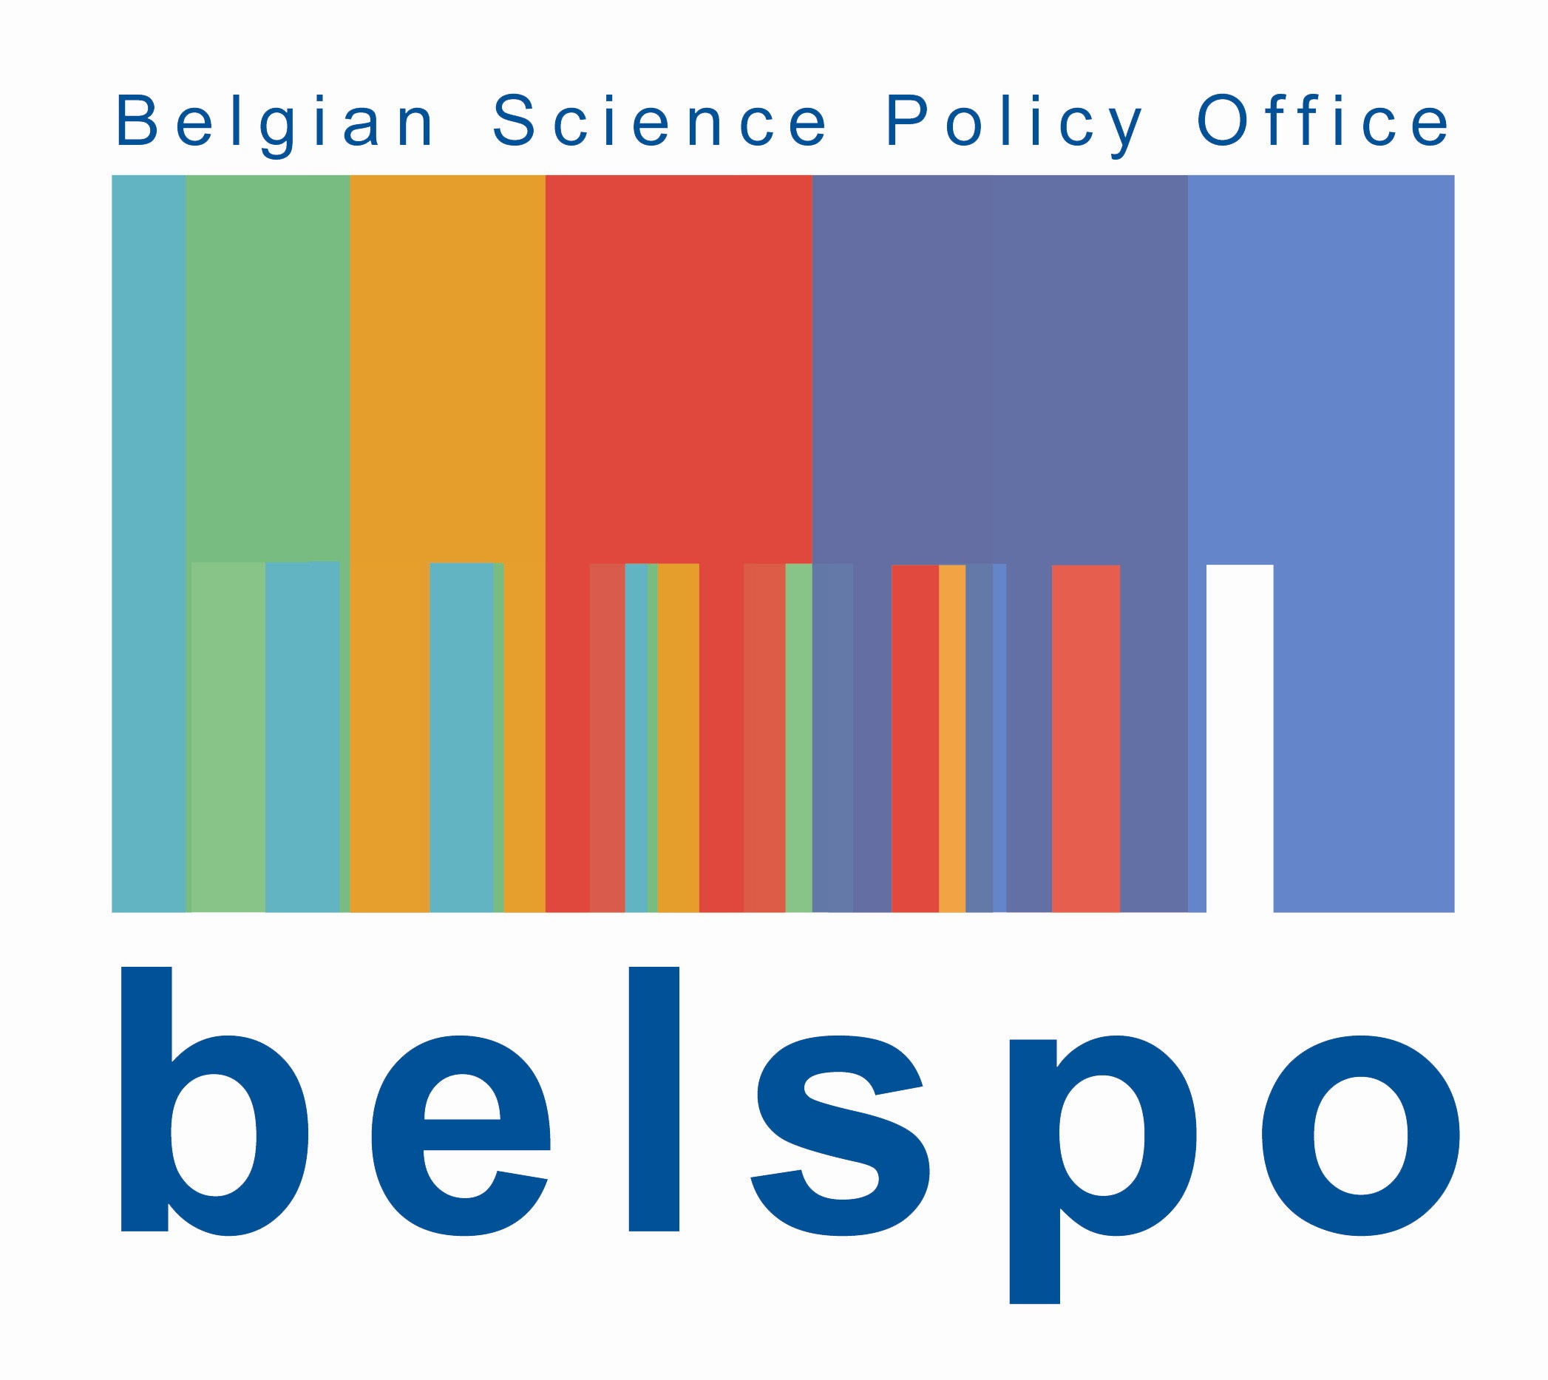

D/XXXX/XXXX/XX (to complete by Belspo)
Published in 20XX by the Belgian Science Policy
Avenue Louise 231
Louizalaan 231
B-1050 Brussels
Belgium
Tel: +32 (0)2 238 34 11 – Fax: +32 (0)2 230 59 12
http://www.belspo.be

Contact person: XXXXXXXX
+32 (0)2 238 3X XX

Neither the Belgian Science Policy nor any person acting on behalf of the Belgian Science Policy is responsible for the use which might be made of the following information. The authors are responsible for the content.
No part of this publication may be reproduced, stored in a retrieval system, or transmitted in any form or by any means, electronic, mechanical, photocopying, recording, or otherwise, without indicating the reference :
Auteurs. Titre. Final Report. Brussels : Belgian Science Policy 2009 – xx p. (Research Programme Science for a Sustainable Development)
TABLE OF CONTENT

